# Archivo:Logo Instituto Politécnico Nacional.png - Wikipedia, la enciclopedia libreArchivo:EscudoESCOM.png - Wikipedia, la enciclopedia libreINSTITUTO POLITÉCNICO NACIONAL

# ESCUELA SUPERIOR DE CÓMPUTO

Vargas Hernández Carlo Ariel

Análisis de algoritmos

3CM15

Ejercicios 13



Índice

**Ejercicio 1:** 1

Prim: 1

Kruskal: 9

Dijkstra: 17

**Ejercicio 2:** 18

Prim: 18

Kruskal: 22

Dijkstra: 29

**Ejercicio 3:** 30

Prim: 30

Kruskal: 39

Dijkstra: 56

**Ejercicio 4:** 57

Prim: 57

Kruskal: 63

Dijkstra: 68

**Ejercicio 5:** 69

Prim: 69

Kruskal: 77

Dijkstra: 103

# **Ejercicio 1:**

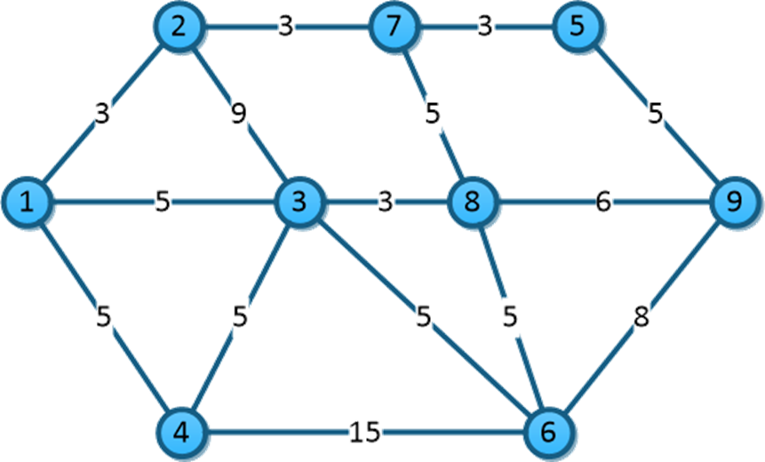

## Prim:

Iniciamos en 1. Llenamos todos con infinito menos el 1 ya que ya estamos ahí.

|  |  |  |  |  |  |  |  |  |
| --- | --- | --- | --- | --- | --- | --- | --- | --- |
| 1 | 2 | 3 | 4 | 5 | 6 | 7 | 8 | 9 |
| 0 | ∞ | ∞ | ∞ | ∞ | ∞ | ∞ | ∞ | ∞ |

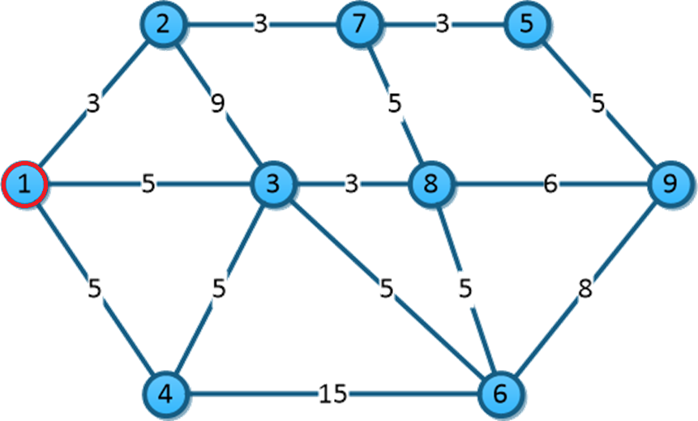

De aquí nos podemos a los nodos 2, 3 y 4. Como las aristas de valor 3, 5 y 5 son menores que ∞ actualizamos el valor. Y tomo la arista con menos peso.

|  |  |  |  |  |  |  |  |  |
| --- | --- | --- | --- | --- | --- | --- | --- | --- |
| 1 | 2 | 3 | 4 | 5 | 6 | 7 | 8 | 9 |
| **0** | 3 | 5 | 5 | ∞ | ∞ | ∞ | ∞ | ∞ |

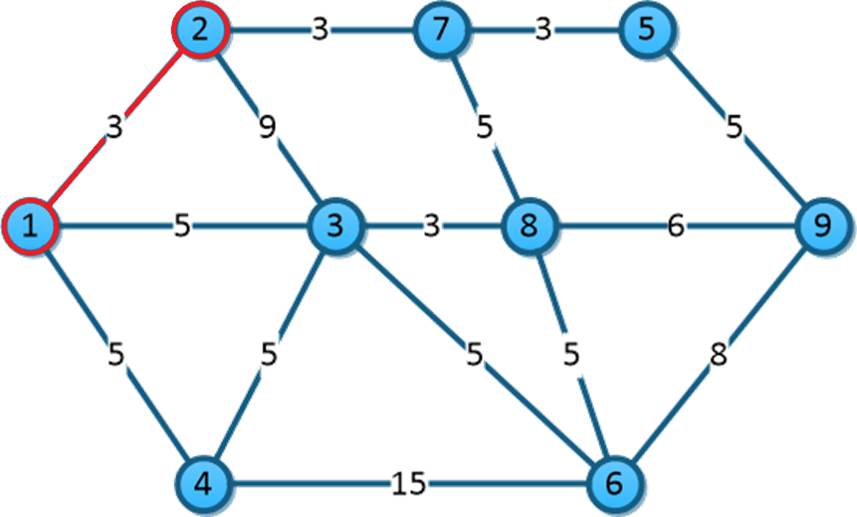

De 2 podemos ir a 3 y 7. 9 no es menor que 5 pero 3 si es menor que ∞. Y tomo la arista 2-7

|  |  |  |  |  |  |  |  |  |
| --- | --- | --- | --- | --- | --- | --- | --- | --- |
| 1 | 2 | 3 | 4 | 5 | 6 | 7 | 8 | 9 |
| **0** | 3 | 5 | 5 | ∞ | ∞ | 3 | ∞ | ∞ |

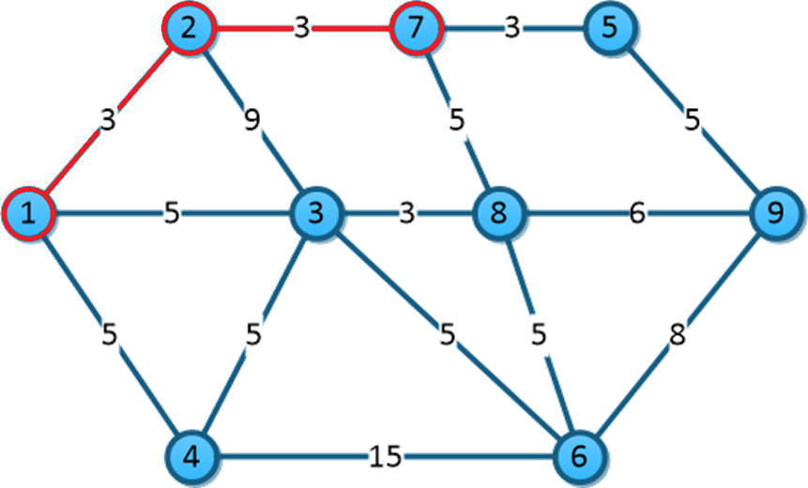

De 7-8 5<∞ y 7-5 3<∞, tomo 7-5.

|  |  |  |  |  |  |  |  |  |
| --- | --- | --- | --- | --- | --- | --- | --- | --- |
| 1 | 2 | 3 | 4 | 5 | 6 | 7 | 8 | 9 |
| **0** | 3 | 5 | 5 | 3 | ∞ | 3 | 5 | ∞ |

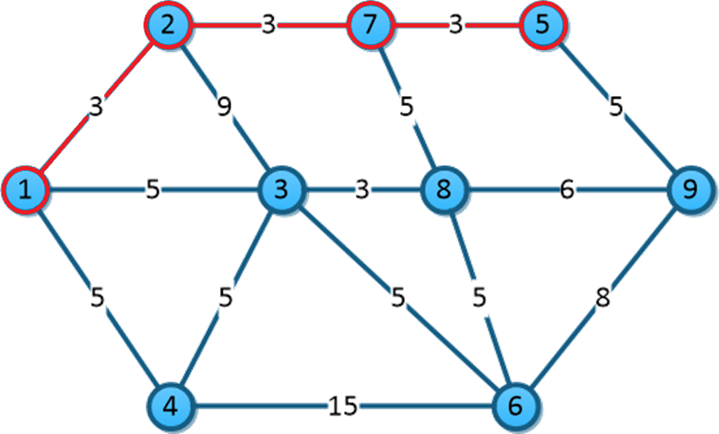

De 5-9 5<∞. Como todos los no visitados valen 5 menos 6 que es ∞ voy a tomar 9 ya que es al que me puedo mover desde 5.

|  |  |  |  |  |  |  |  |  |
| --- | --- | --- | --- | --- | --- | --- | --- | --- |
| 1 | 2 | 3 | 4 | 5 | 6 | 7 | 8 | 9 |
| **0** | 3 | 5 | 5 | 3 | ∞ | 3 | 5 | 5 |

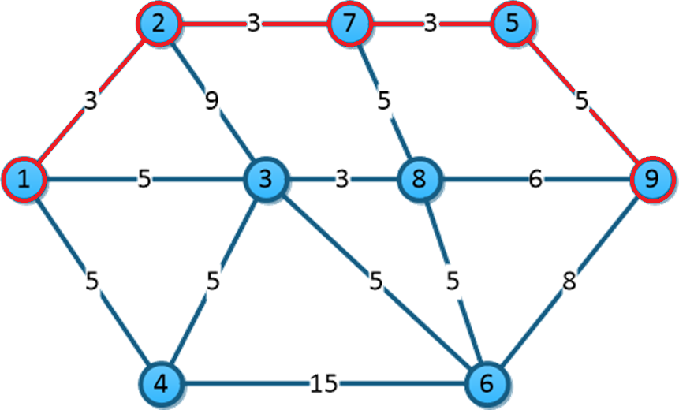

De 9-8 5<6, no se cambia. De 9-6 8<∞. Como todos valen 5 menos el vértice 6, voy a tomar 3.

|  |  |  |  |  |  |  |  |  |
| --- | --- | --- | --- | --- | --- | --- | --- | --- |
| 1 | 2 | 3 | 4 | 5 | 6 | 7 | 8 | 9 |
| **0** | 3 | 5 | 5 | 3 | 8 | 3 | 5 | 5 |

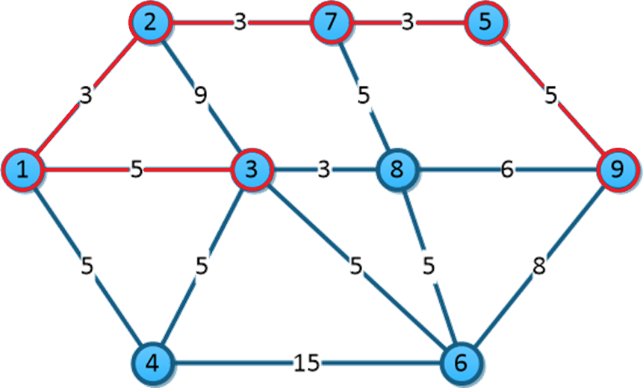

De 3-4 5=5, es igual. 3-6 5<8 se cambia. De 3-8 3<5 se cambia. Se toma este último porque es el menor.

|  |  |  |  |  |  |  |  |  |
| --- | --- | --- | --- | --- | --- | --- | --- | --- |
| 1 | 2 | 3 | 4 | 5 | 6 | 7 | 8 | 9 |
| **0** | 3 | 5 | 5 | 3 | 5 | 3 | 3 | 5 |

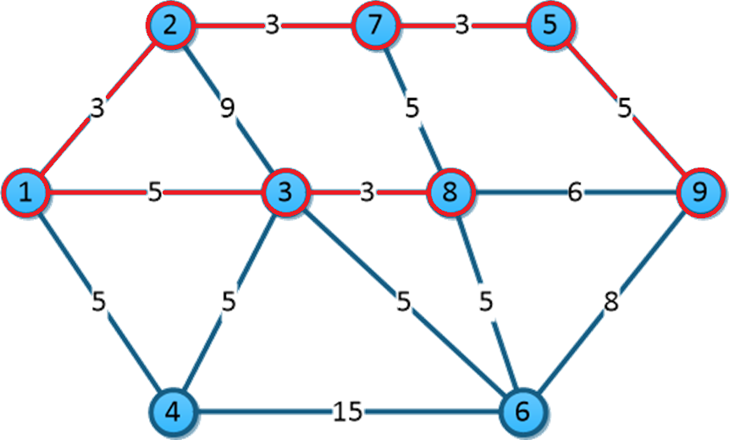

De 8-6 5=5 es igual. Como todos son 5 nos movemos a 4.

|  |  |  |  |  |  |  |  |  |
| --- | --- | --- | --- | --- | --- | --- | --- | --- |
| 1 | 2 | 3 | 4 | 5 | 6 | 7 | 8 | 9 |
| **0** | 3 | 5 | 5 | 3 | 5 | 3 | 3 | 5 |

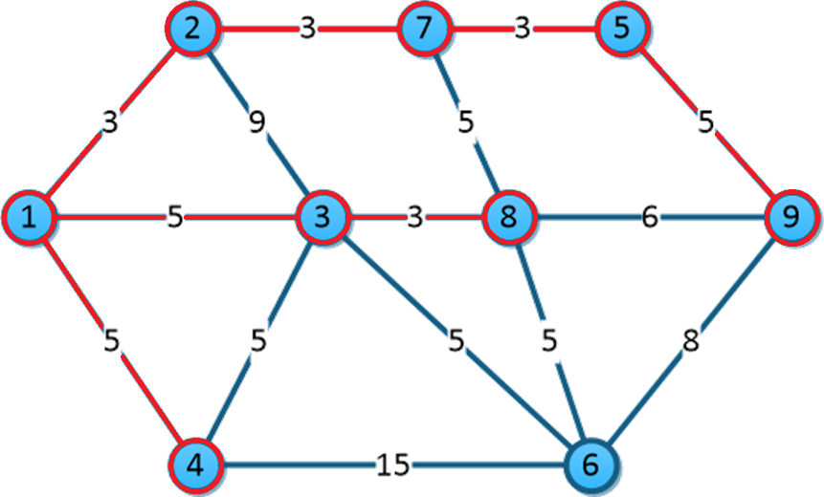

De 4-6, 5<15 no se cambia. Se toma el último.

|  |  |  |  |  |  |  |  |  |
| --- | --- | --- | --- | --- | --- | --- | --- | --- |
| 1 | 2 | 3 | 4 | 5 | 6 | 7 | 8 | 9 |
| **0** | 3 | 5 | 5 | 3 | 5 | 3 | 3 | 5 |

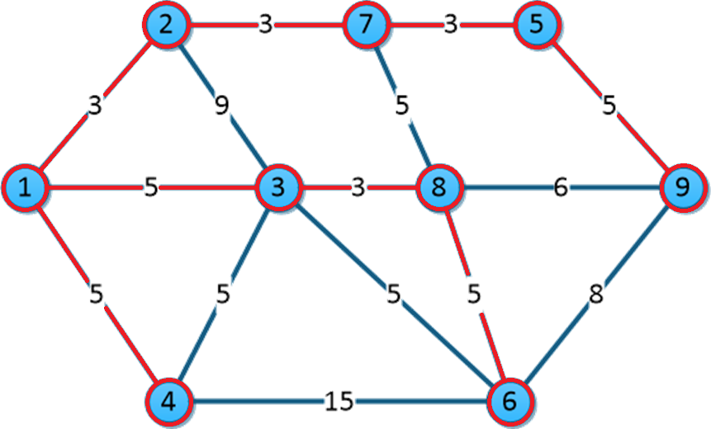

## Kruskal:

Ordenamos las aristas:

|  |  |
| --- | --- |
| 1-2 | 3 |
| 2-7 | 3 |
| 7-5 | 3 |
| 3-8 | 3 |
| 1-3 | 5 |
| 1-4 | 5 |
| 3-4 | 5 |
| 3-6 | 5 |
| 5-9 | 5 |
| 6-8 | 5 |
| 7-8 | 5 |
| 8-9 | 6 |
| 6-9 | 8 |
| 2-3 | 9 |
| 4-6 | 15 |

Tomamos 1-2.

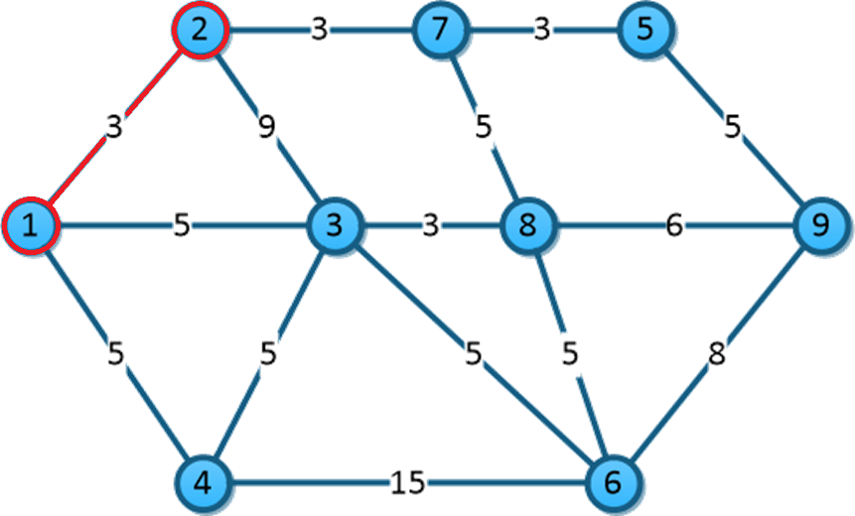

|  |  |
| --- | --- |
| 1-2 | 3 |
| 2-7 | 3 |
| 7-5 | 3 |
| 3-8 | 3 |
| 1-3 | 5 |
| 1-4 | 5 |
| 3-4 | 5 |
| 3-6 | 5 |
| 5-9 | 5 |
| 6-8 | 5 |
| 7-8 | 5 |
| 8-9 | 6 |
| 6-9 | 8 |
| 2-3 | 9 |
| 4-6 | 15 |

Tomamos 2-7 porque no forma ciclo.

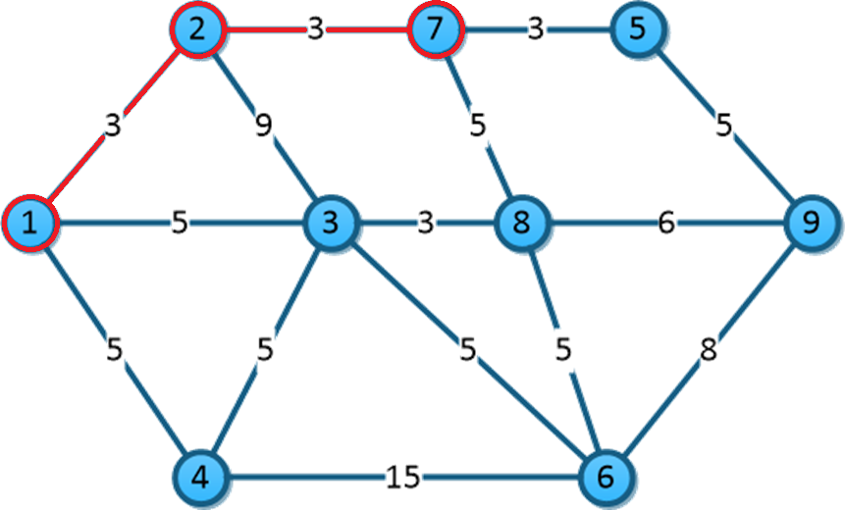

|  |  |
| --- | --- |
| 1-2 | 3 |
| 2-7 | 3 |
| 7-5 | 3 |
| 3-8 | 3 |
| 1-3 | 5 |
| 1-4 | 5 |
| 3-4 | 5 |
| 3-6 | 5 |
| 5-9 | 5 |
| 6-8 | 5 |
| 7-8 | 5 |
| 8-9 | 6 |
| 6-9 | 8 |
| 2-3 | 9 |
| 4-6 | 15 |

Tomamos 7-5 porque no forma ciclo.

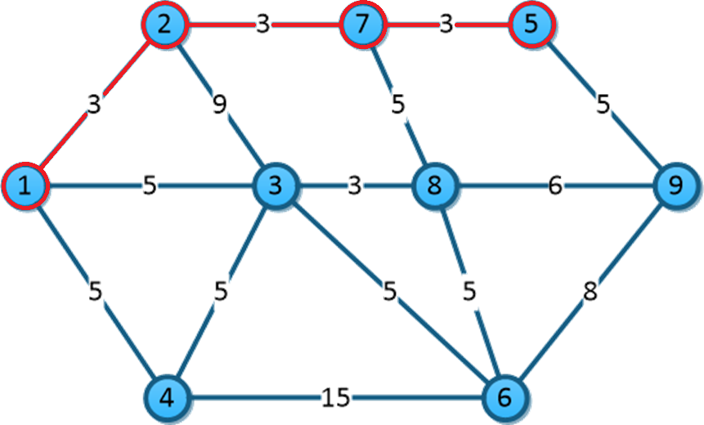

|  |  |
| --- | --- |
| 1-2 | 3 |
| 2-7 | 3 |
| 7-5 | 3 |
| 3-8 | 3 |
| 1-3 | 5 |
| 1-4 | 5 |
| 3-4 | 5 |
| 3-6 | 5 |
| 5-9 | 5 |
| 6-8 | 5 |
| 7-8 | 5 |
| 8-9 | 6 |
| 6-9 | 8 |
| 2-3 | 9 |
| 4-6 | 15 |

Tomamos 3-8 ya que no forma ciclo.

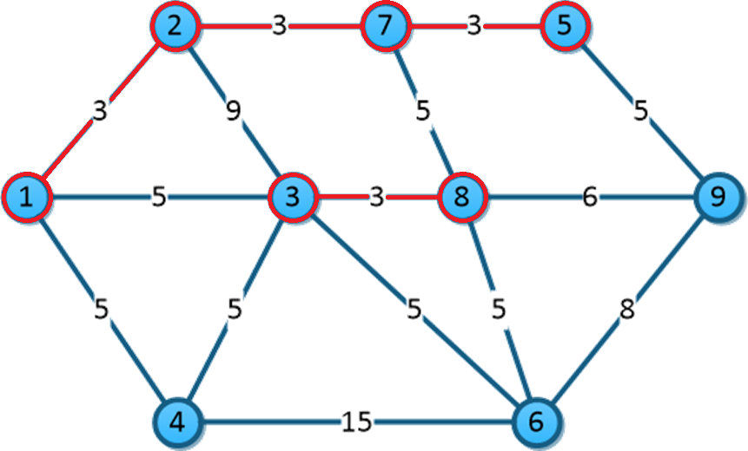

|  |  |
| --- | --- |
| 1-2 | 3 |
| 2-7 | 3 |
| 7-5 | 3 |
| 3-8 | 3 |
| 1-3 | 5 |
| 1-4 | 5 |
| 3-4 | 5 |
| 3-6 | 5 |
| 5-9 | 5 |
| 6-8 | 5 |
| 7-8 | 5 |
| 8-9 | 6 |
| 6-9 | 8 |
| 2-3 | 9 |
| 4-6 | 15 |

Tomamos 1-3.

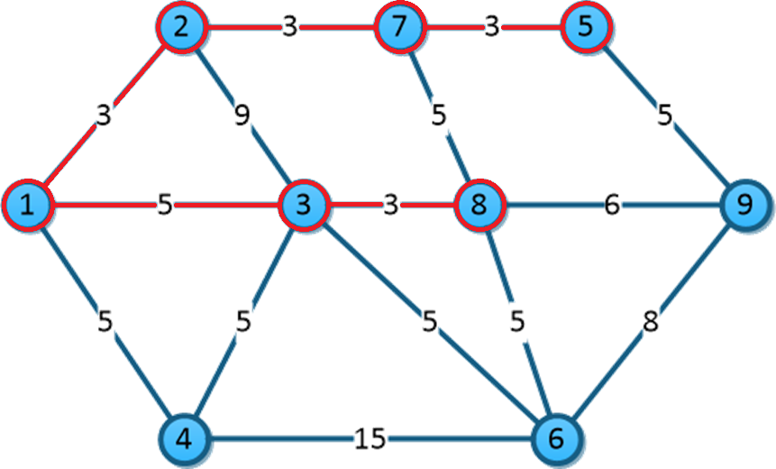

|  |  |
| --- | --- |
| 1-2 | 3 |
| 2-7 | 3 |
| 7-5 | 3 |
| 3-8 | 3 |
| 1-3 | 5 |
| 1-4 | 5 |
| 3-4 | 5 |
| 3-6 | 5 |
| 5-9 | 5 |
| 6-8 | 5 |
| 7-8 | 5 |
| 8-9 | 6 |
| 6-9 | 8 |
| 2-3 | 9 |
| 4-6 | 15 |

Tomamos 1-4.

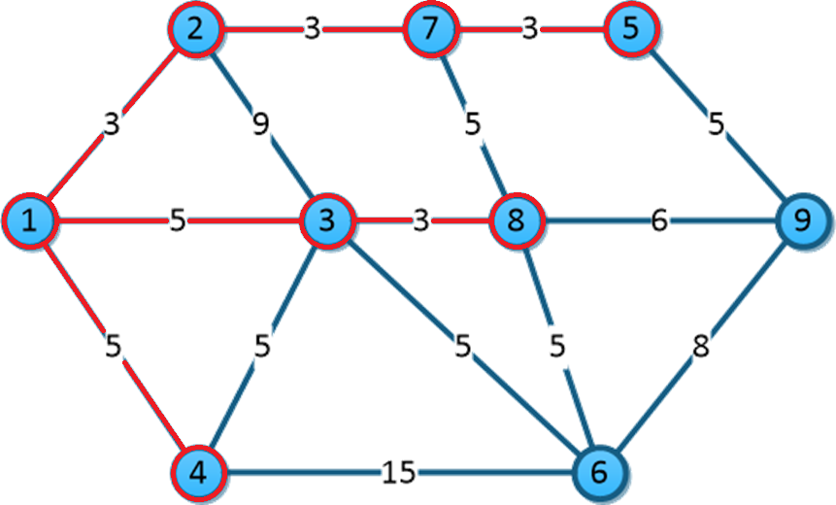

|  |  |
| --- | --- |
| 1-2 | 3 |
| 2-7 | 3 |
| 7-5 | 3 |
| 3-8 | 3 |
| 1-3 | 5 |
| 1-4 | 5 |
| 3-4 | 5 |
| 3-6 | 5 |
| 5-9 | 5 |
| 6-8 | 5 |
| 7-8 | 5 |
| 8-9 | 6 |
| 6-9 | 8 |
| 2-3 | 9 |
| 4-6 | 15 |

No tomamos 3-4 porque forma un ciclo mejor tomamos 3-6.

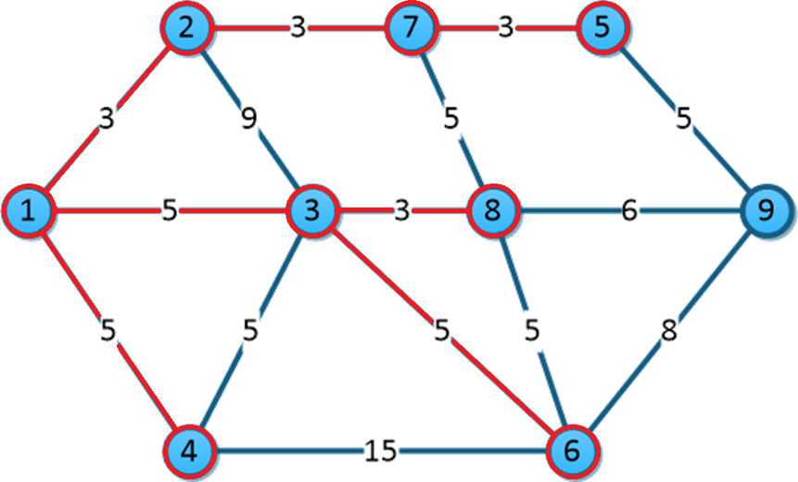

|  |  |
| --- | --- |
| 1-2 | 3 |
| 2-7 | 3 |
| 7-5 | 3 |
| 3-8 | 3 |
| 1-3 | 5 |
| 1-4 | 5 |
| ~~3-4~~ | ~~5~~ |
| 3-6 | 5 |
| 5-9 | 5 |
| 6-8 | 5 |
| 7-8 | 5 |
| 8-9 | 6 |
| 6-9 | 8 |
| 2-3 | 9 |
| 4-6 | 15 |

Tomamos 5-9.

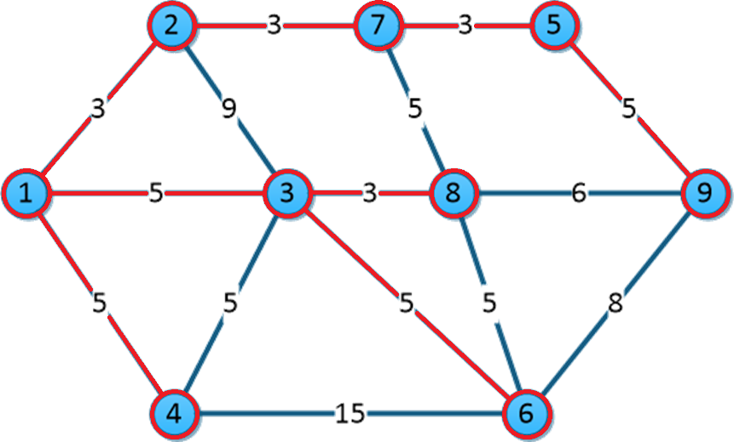

Como ya toque todos los nodos ya terminé.

## Dijkstra:

Camino más corto de 1 a 9.

|  |  |  |  |  |
| --- | --- | --- | --- | --- |
| Vértice |  |  |  |  |
| 1 | (0,1) | * | * | * |
| 2 | (3,1)-> | (3,1) | * | * |
| 3 | (5,1) | (12,2) | ∞ | * |
| 4 | ∞ | ∞ | ∞ | * |
| 5 | ∞ | ∞ | (9,7)-> | (9,7) |
| 6 | ∞ | ∞ | ∞ | * |
| 7 | ∞ | (6,2)-> | (6,2) | * |
| 8 | ∞ | ∞ | (11,7) | * |
| 9 | ∞ | ∞ | ∞ | * |

# **Ejercicio 2:**

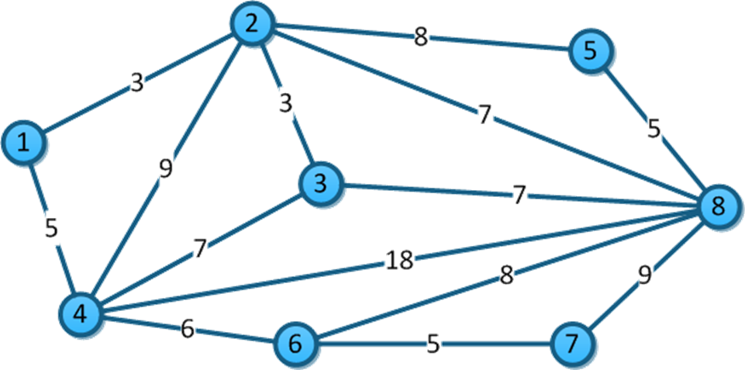

## Prim:

Seleccionamos 1 como inicio, le asignamos 0 llenamos los demás con ∞.

|  |  |  |  |  |  |  |  |
| --- | --- | --- | --- | --- | --- | --- | --- |
| 1 | 2 | 3 | 4 | 5 | 6 | 7 | 8 |
| 0 | ∞ | ∞ | ∞ | ∞ | ∞ | ∞ | ∞ |

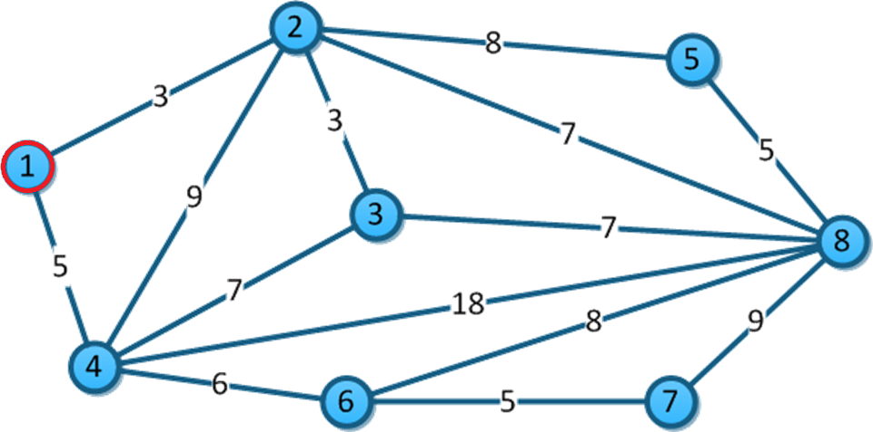

De 1-2, 3<∞ se cambia. De 1-4 5<∞, se cambia. Nos movemos a nodo 2.

|  |  |  |  |  |  |  |  |
| --- | --- | --- | --- | --- | --- | --- | --- |
| 1 | 2 | 3 | 4 | 5 | 6 | 7 | 8 |
| 0 | 3 | ∞ | 5 | ∞ | ∞ | ∞ | ∞ |

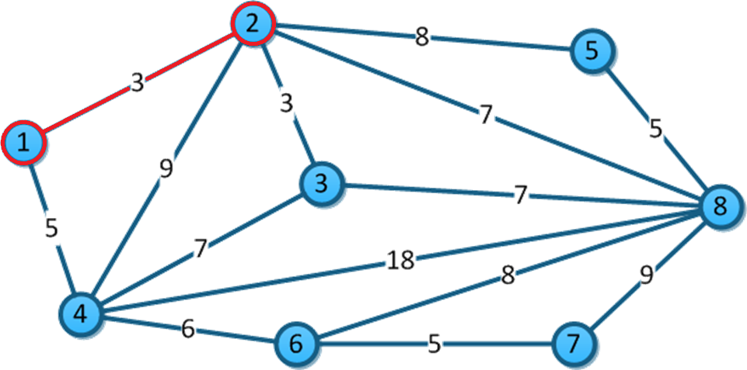

De 2-3, 3<∞ se cambia. De 2-4, 9>5 no se cambia. De 2-5, 8<∞ se cambia. De 2-8, 7<∞ se cambia. Nos movemos a nodo 3.

|  |  |  |  |  |  |  |  |
| --- | --- | --- | --- | --- | --- | --- | --- |
| 1 | 2 | 3 | 4 | 5 | 6 | 7 | 8 |
| 0 | 3 | 3 | 5 | 8 | ∞ | ∞ | 7 |

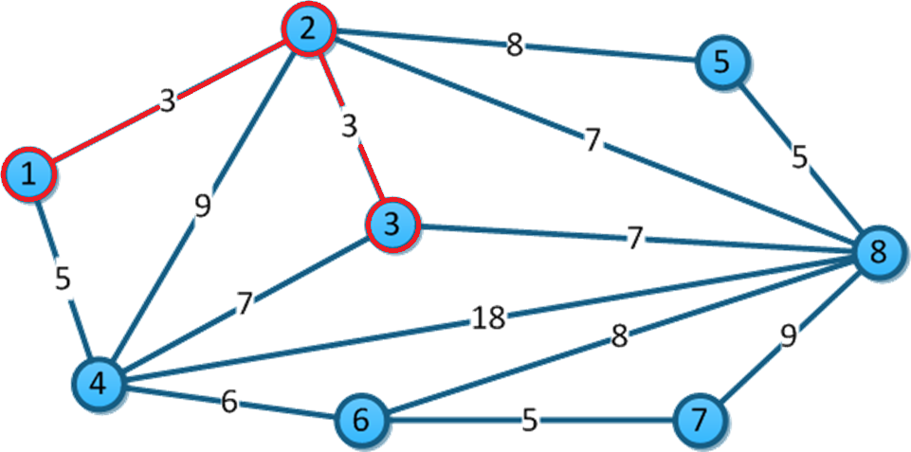

De 3-4, 7>5 no se cambia. 3-8 7=7 es igual. Me muevo a nodo 4.

|  |  |  |  |  |  |  |  |
| --- | --- | --- | --- | --- | --- | --- | --- |
| 1 | 2 | 3 | 4 | 5 | 6 | 7 | 8 |
| 0 | 3 | 3 | 5 | 8 | ∞ | ∞ | 7 |

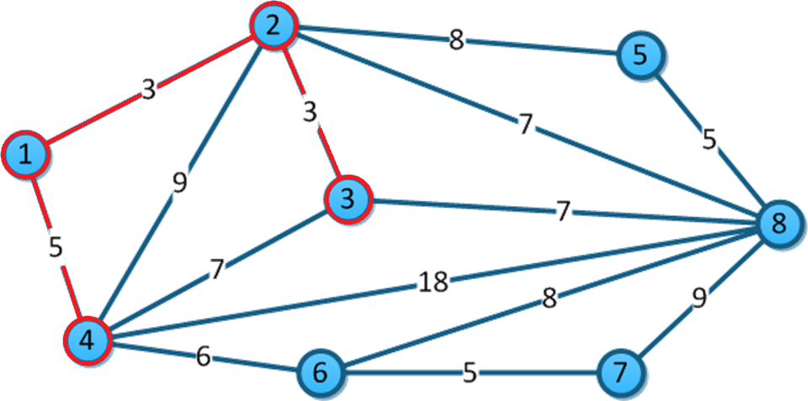

De 4-6, 6<∞ se cambia. De 4-8 18>7 no se cambia. Nos movemos a nodo 6.

|  |  |  |  |  |  |  |  |
| --- | --- | --- | --- | --- | --- | --- | --- |
| 1 | 2 | 3 | 4 | 5 | 6 | 7 | 8 |
| 0 | 3 | 3 | 5 | 8 | 6 | ∞ | 7 |

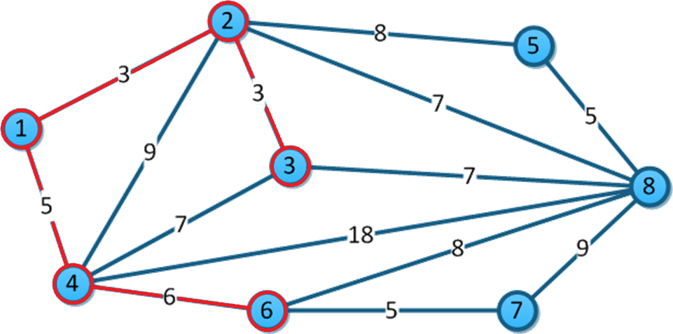

De 6-7 5<∞ se cambia. De 6-8 8>7 no se cambia. Nos movemos al nodo 7.

|  |  |  |  |  |  |  |  |
| --- | --- | --- | --- | --- | --- | --- | --- |
| 1 | 2 | 3 | 4 | 5 | 6 | 7 | 8 |
| 0 | 3 | 3 | 5 | 8 | 6 | 5 | 7 |

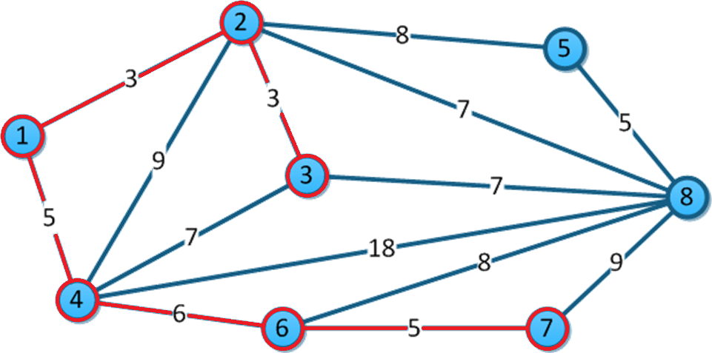

De 7-8, 9>7 no se cambia. Nos movemos a 8.

|  |  |  |  |  |  |  |  |
| --- | --- | --- | --- | --- | --- | --- | --- |
| 1 | 2 | 3 | 4 | 5 | 6 | 7 | 8 |
| 0 | 3 | 3 | 5 | 8 | 6 | 5 | 7 |

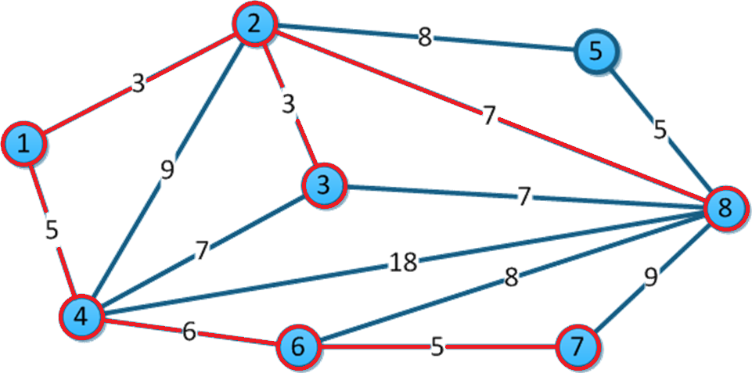

De 8-5, 5<8 se cambia y se toma.

|  |  |  |  |  |  |  |  |
| --- | --- | --- | --- | --- | --- | --- | --- |
| 1 | 2 | 3 | 4 | 5 | 6 | 7 | 8 |
| 0 | 3 | 3 | 5 | 8 | 6 | 5 | 7 |

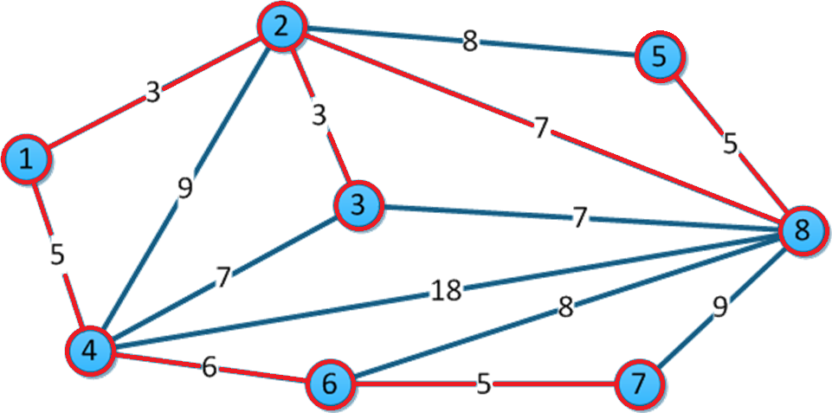

## Kruskal:

Ordenamos las aristas por peso.

|  |  |
| --- | --- |
| 1-2 | 3 |
| 2-3 | 3 |
| 1-4 | 5 |
| 5-8 | 5 |
| 6-7 | 5 |
| 4-6 | 6 |
| 2-8 | 7 |
| 3-4 | 7 |
| 3-8 | 7 |
| 2-5 | 8 |
| 6-8 | 8 |
| 2-4 | 9 |
| 7-8 | 9 |
| 4-8 | 18 |

Tomamos 1-2.

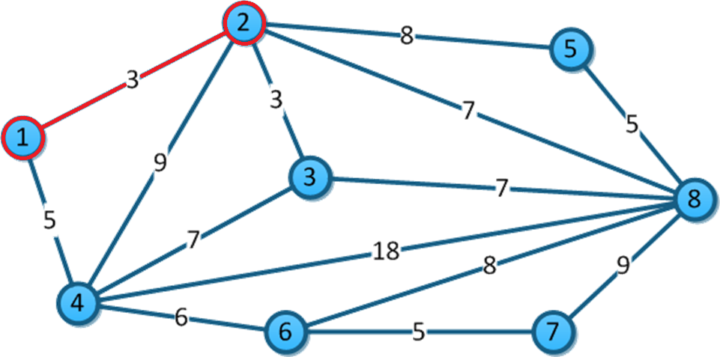

|  |  |
| --- | --- |
| 1-2 | 3 |
| 2-3 | 3 |
| 1-4 | 5 |
| 5-8 | 5 |
| 6-7 | 5 |
| 4-6 | 6 |
| 2-8 | 7 |
| 3-4 | 7 |
| 3-8 | 7 |
| 2-5 | 8 |
| 6-8 | 8 |
| 2-4 | 9 |
| 7-8 | 9 |
| 4-8 | 18 |

Tomamos 2-3.

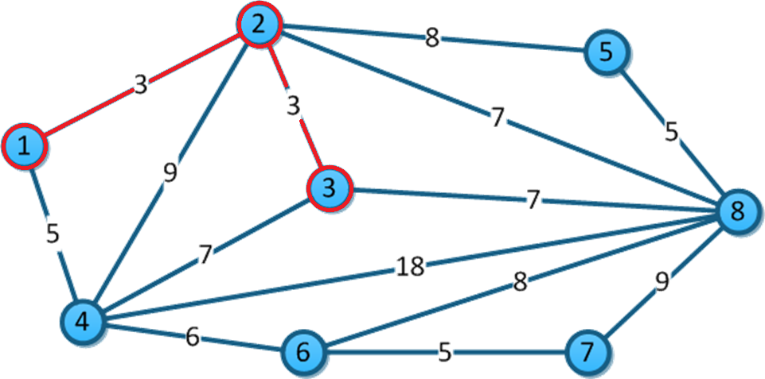

|  |  |
| --- | --- |
| 1-2 | 3 |
| 2-3 | 3 |
| 1-4 | 5 |
| 5-8 | 5 |
| 6-7 | 5 |
| 4-6 | 6 |
| 2-8 | 7 |
| 3-4 | 7 |
| 3-8 | 7 |
| 2-5 | 8 |
| 6-8 | 8 |
| 2-4 | 9 |
| 7-8 | 9 |
| 4-8 | 18 |

Tomamos 1-4.

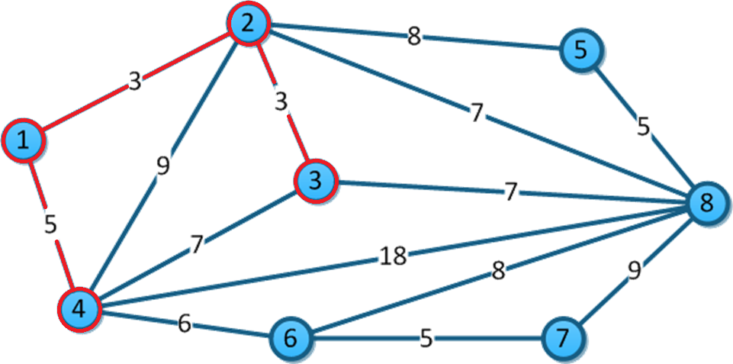

|  |  |
| --- | --- |
| 1-2 | 3 |
| 2-3 | 3 |
| 1-4 | 5 |
| 5-8 | 5 |
| 6-7 | 5 |
| 4-6 | 6 |
| 2-8 | 7 |
| 3-4 | 7 |
| 3-8 | 7 |
| 2-5 | 8 |
| 6-8 | 8 |
| 2-4 | 9 |
| 7-8 | 9 |
| 4-8 | 18 |

Tomamos 5-8.

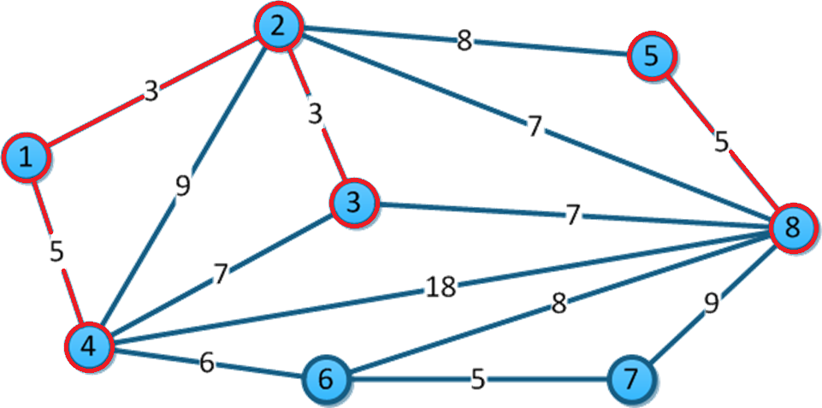

|  |  |
| --- | --- |
| 1-2 | 3 |
| 2-3 | 3 |
| 1-4 | 5 |
| 5-8 | 5 |
| 6-7 | 5 |
| 4-6 | 6 |
| 2-8 | 7 |
| 3-4 | 7 |
| 3-8 | 7 |
| 2-5 | 8 |
| 6-8 | 8 |
| 2-4 | 9 |
| 7-8 | 9 |
| 4-8 | 18 |

Tomamos 6-7.

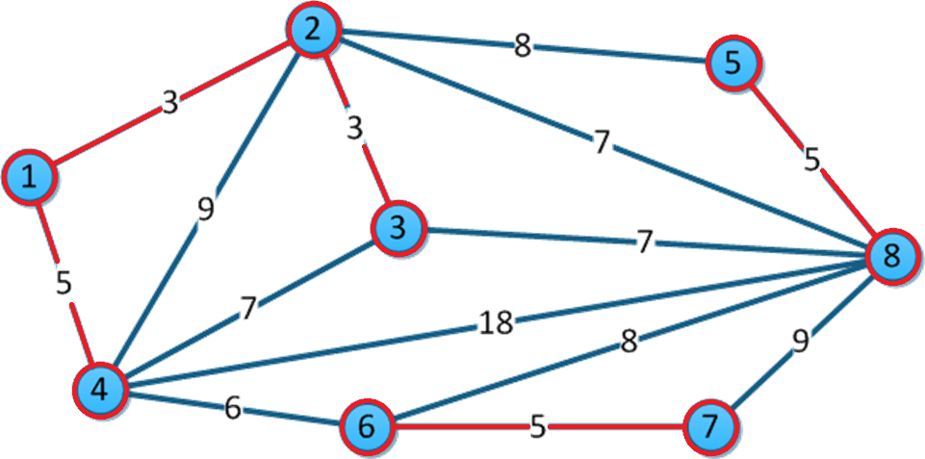

|  |  |
| --- | --- |
| 1-2 | 3 |
| 2-3 | 3 |
| 1-4 | 5 |
| 5-8 | 5 |
| 6-7 | 5 |
| 4-6 | 6 |
| 2-8 | 7 |
| 3-4 | 7 |
| 3-8 | 7 |
| 2-5 | 8 |
| 6-8 | 8 |
| 2-4 | 9 |
| 7-8 | 9 |
| 4-8 | 18 |

Tomamos 4-6.

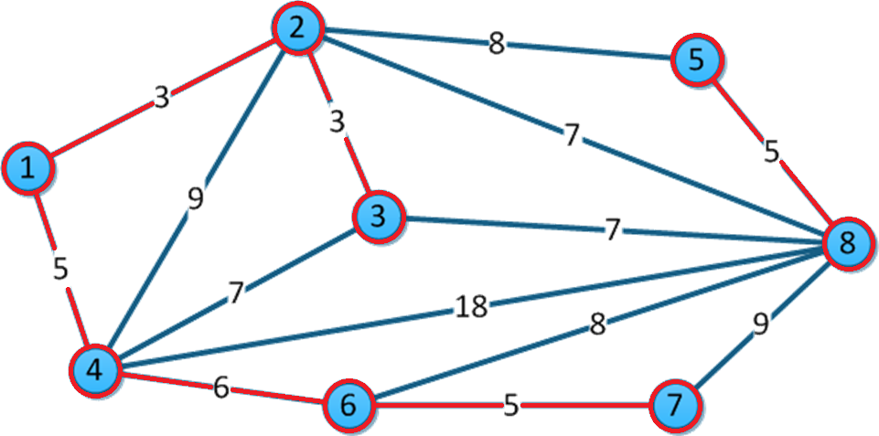

|  |  |
| --- | --- |
| 1-2 | 3 |
| 2-3 | 3 |
| 1-4 | 5 |
| 5-8 | 5 |
| 6-7 | 5 |
| 4-6 | 6 |
| 2-8 | 7 |
| 3-4 | 7 |
| 3-8 | 7 |
| 2-5 | 8 |
| 6-8 | 8 |
| 2-4 | 9 |
| 7-8 | 9 |
| 4-8 | 18 |

Tomamos 2-8. Y al usar todos los nodos terminamos.

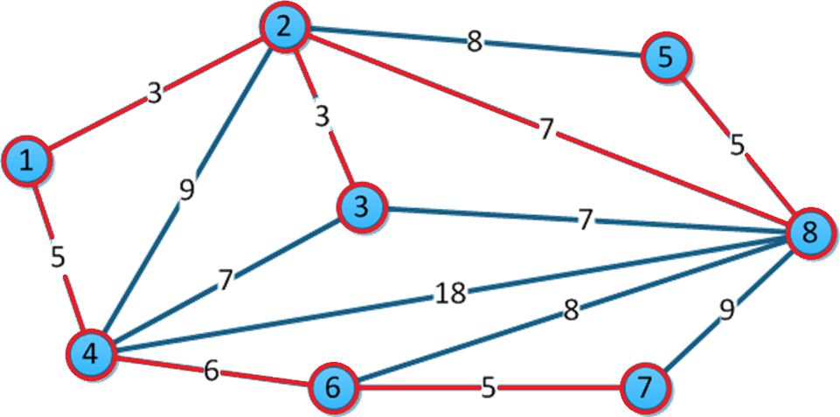

## Dijkstra:

Camino más corto de 1 a 8.

|  |  |  |  |
| --- | --- | --- | --- |
| Vértice |  |  |  |
| 1 | (0,1) | * | * |
| 2 | (3,1)-> | (3,1) | * |
| 3 | ∞ | (6,2) | * |
| 4 | (5,1) | (12,2) | * |
| 5 | ∞ | (11,2) | * |
| 6 | ∞ | ∞ | * |
| 7 | ∞ | ∞ | * |
| 8 | ∞ | (10,2)-> | (10,2) |

# **Ejercicio 3:**

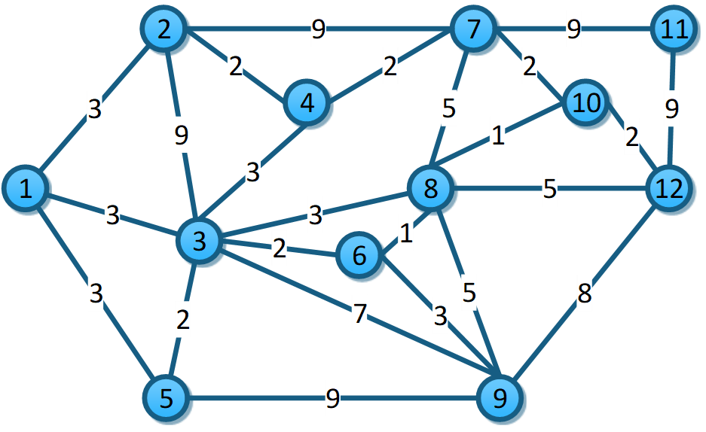

## Prim:

Iniciamos en 1, le asignamos 0 a los demás ∞.

|  |  |  |  |  |  |  |  |  |  |  |  |
| --- | --- | --- | --- | --- | --- | --- | --- | --- | --- | --- | --- |
| 1 | 2 | 3 | 4 | 5 | 6 | 7 | 8 | 9 | 10 | 11 | 12 |
| 0 | ∞ | ∞ | ∞ | ∞ | ∞ | ∞ | ∞ | ∞ | ∞ | ∞ | ∞ |

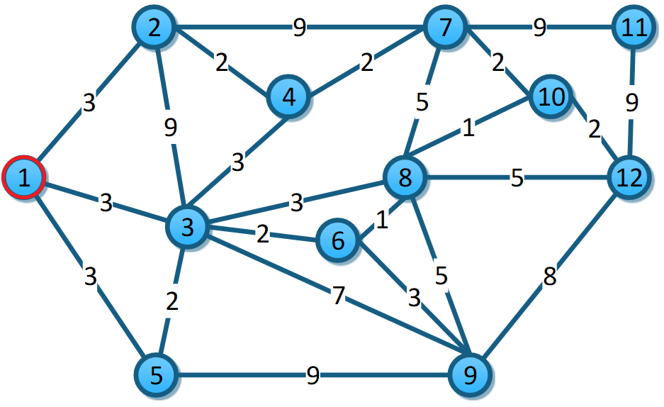

De 1-2, 3<∞ se cambia. De 1-3, 3<∞ se cambia. De 1-5, 3<∞ se cambia. Nos movemos a nodo 2.

|  |  |  |  |  |  |  |  |  |  |  |  |
| --- | --- | --- | --- | --- | --- | --- | --- | --- | --- | --- | --- |
| 1 | 2 | 3 | 4 | 5 | 6 | 7 | 8 | 9 | 10 | 11 | 12 |
| 0 | 3 | 3 | ∞ | 3 | ∞ | ∞ | ∞ | ∞ | ∞ | ∞ | ∞ |

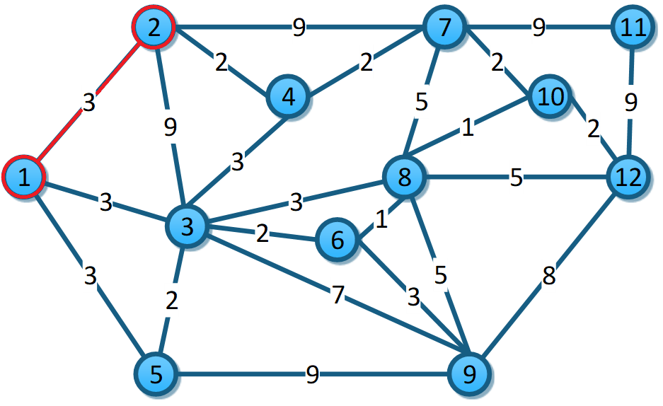

De 2-3, 9>3 no se toma. De 2-4, 2<∞ se cambia. De 2-7, 9<∞ se cambia. Nos movemos al nodo 4.

|  |  |  |  |  |  |  |  |  |  |  |  |
| --- | --- | --- | --- | --- | --- | --- | --- | --- | --- | --- | --- |
| 1 | 2 | 3 | 4 | 5 | 6 | 7 | 8 | 9 | 10 | 11 | 12 |
| 0 | 3 | 3 | 2 | 3 | ∞ | 9 | ∞ | ∞ | ∞ | ∞ | ∞ |

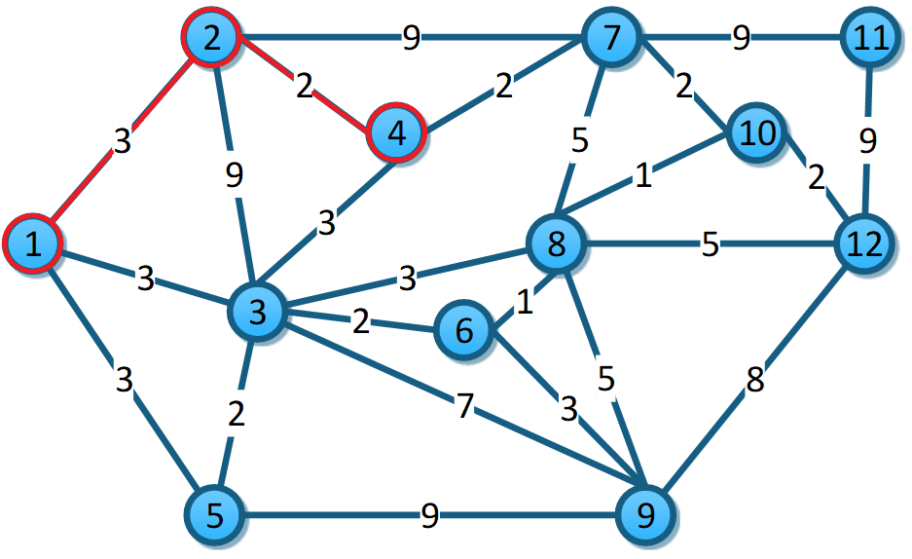

De 4-7, 2<9 se cambia. De 4-3, 3=3 es igual. Nos movemos al menor que es 2 de 4-7.

|  |  |  |  |  |  |  |  |  |  |  |  |
| --- | --- | --- | --- | --- | --- | --- | --- | --- | --- | --- | --- |
| 1 | 2 | 3 | 4 | 5 | 6 | 7 | 8 | 9 | 10 | 11 | 12 |
| 0 | 3 | 3 | 2 | 3 | ∞ | 2 | ∞ | ∞ | ∞ | ∞ | ∞ |

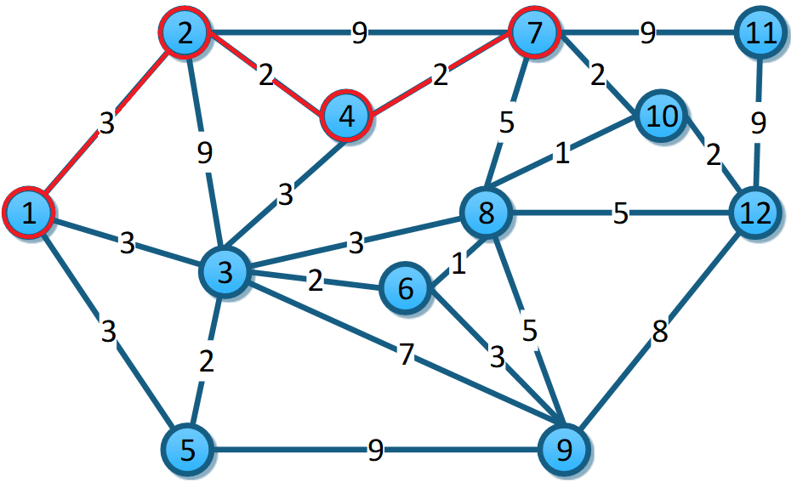

De 7-8, 5<∞ se cambia. De 7-10, 2<∞ se cambia. De 7-11 9<∞ se cambia. Nos movemos a nodo 10.

|  |  |  |  |  |  |  |  |  |  |  |  |
| --- | --- | --- | --- | --- | --- | --- | --- | --- | --- | --- | --- |
| 1 | 2 | 3 | 4 | 5 | 6 | 7 | 8 | 9 | 10 | 11 | 12 |
| 0 | 3 | 3 | 2 | 3 | ∞ | 2 | 5 | ∞ | 2 | 9 | ∞ |

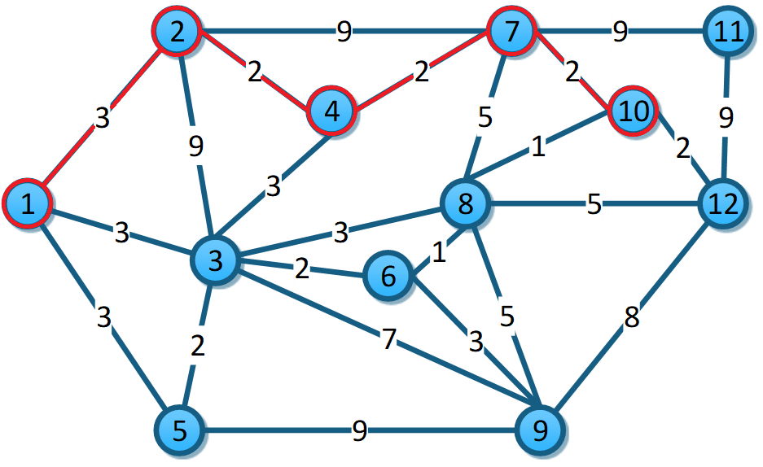

De 10-8, 1<5 se cambia. 10-12, 2<∞ se cambia. Nos movemos a nodo 8.

|  |  |  |  |  |  |  |  |  |  |  |  |
| --- | --- | --- | --- | --- | --- | --- | --- | --- | --- | --- | --- |
| 1 | 2 | 3 | 4 | 5 | 6 | 7 | 8 | 9 | 10 | 11 | 12 |
| 0 | 3 | 3 | 2 | 3 | ∞ | 2 | 1 | ∞ | 2 | 9 | 2 |

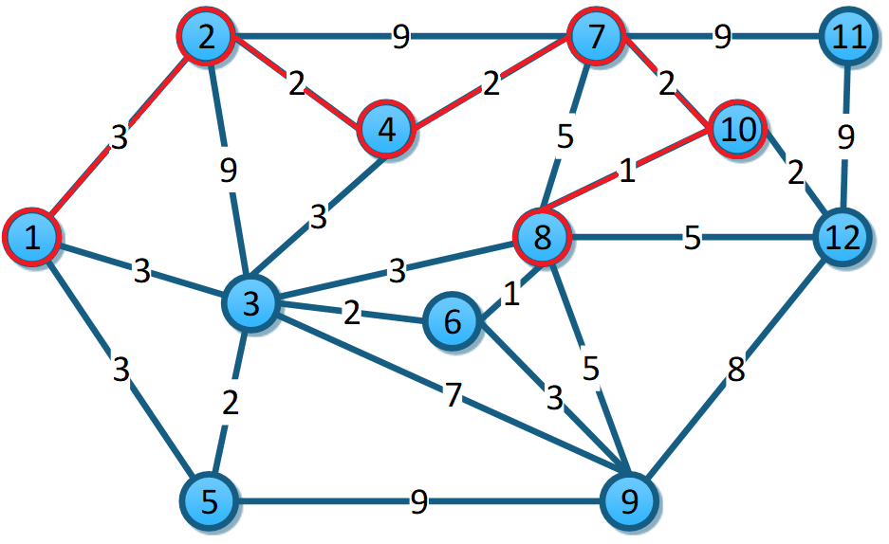

De 8-3, 3=3 es igual. De 8-6, 1<∞ se cambia. De 8-9, 5<∞ se cambia. 8-12, 5>2 no se cambia. Vamos a nodo 6.

|  |  |  |  |  |  |  |  |  |  |  |  |
| --- | --- | --- | --- | --- | --- | --- | --- | --- | --- | --- | --- |
| 1 | 2 | 3 | 4 | 5 | 6 | 7 | 8 | 9 | 10 | 11 | 12 |
| 0 | 3 | 3 | 2 | 3 | 1 | 2 | 1 | 5 | 2 | 9 | 2 |

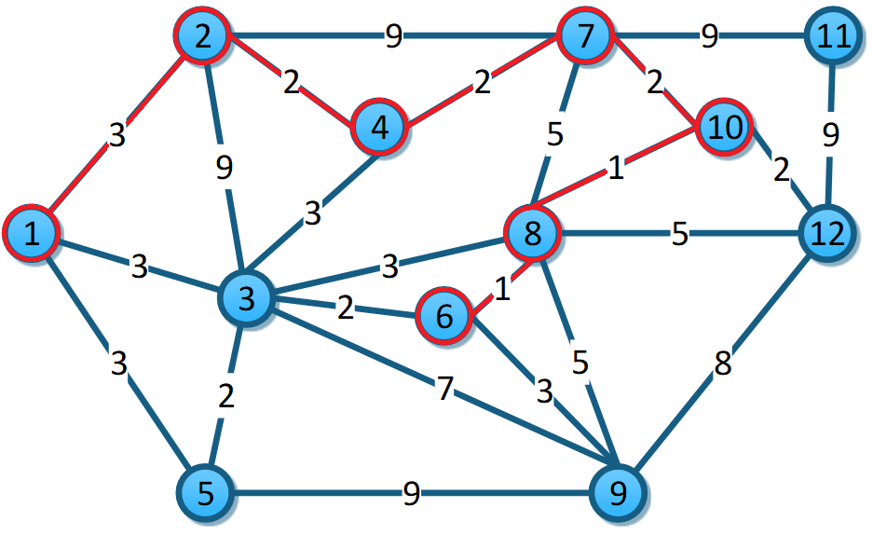

De 6-3, 2<3 se cambia. De 6-9, 3<5 se cambia. Tomamos el nodo 3.

|  |  |  |  |  |  |  |  |  |  |  |  |
| --- | --- | --- | --- | --- | --- | --- | --- | --- | --- | --- | --- |
| 1 | 2 | 3 | 4 | 5 | 6 | 7 | 8 | 9 | 10 | 11 | 12 |
| 0 | 3 | 2 | 2 | 3 | 1 | 2 | 1 | 3 | 2 | 9 | 2 |

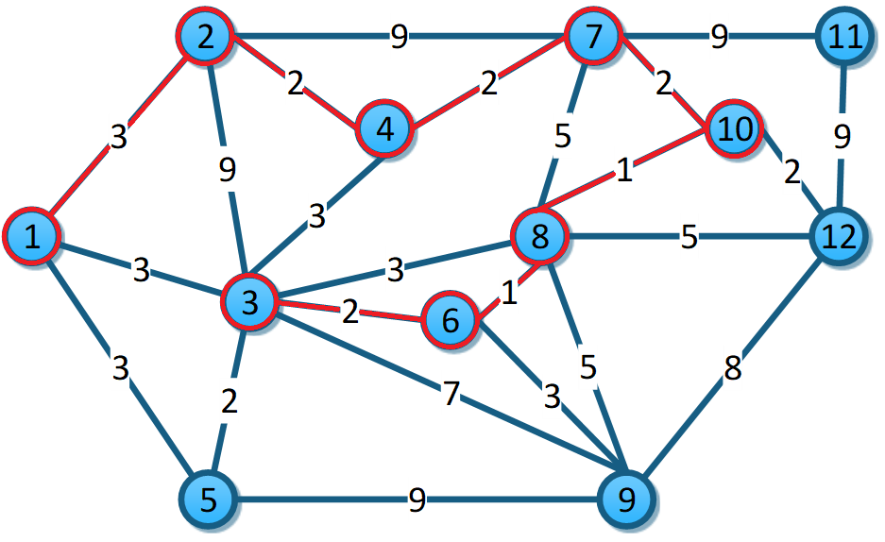

De 3-5, 2<3 se cambia. Tomamos nodo 5.

|  |  |  |  |  |  |  |  |  |  |  |  |
| --- | --- | --- | --- | --- | --- | --- | --- | --- | --- | --- | --- |
| 1 | 2 | 3 | 4 | 5 | 6 | 7 | 8 | 9 | 10 | 11 | 12 |
| 0 | 3 | 2 | 2 | 2 | 1 | 2 | 1 | 3 | 2 | 9 | 2 |

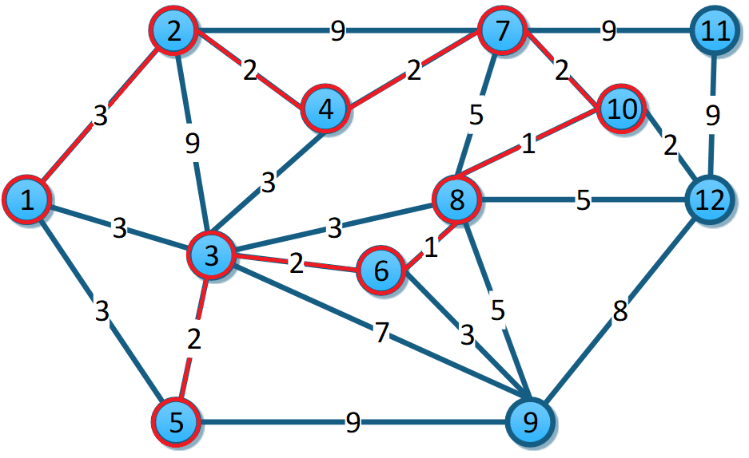

De 5-9, 9>3 no se cambia. Tomamos el nodo con menor peso asignado que es el nodo 12.

|  |  |  |  |  |  |  |  |  |  |  |  |
| --- | --- | --- | --- | --- | --- | --- | --- | --- | --- | --- | --- |
| 1 | 2 | 3 | 4 | 5 | 6 | 7 | 8 | 9 | 10 | 11 | 12 |
| 0 | 3 | 2 | 2 | 2 | 1 | 2 | 1 | 3 | 2 | 9 | 2 |

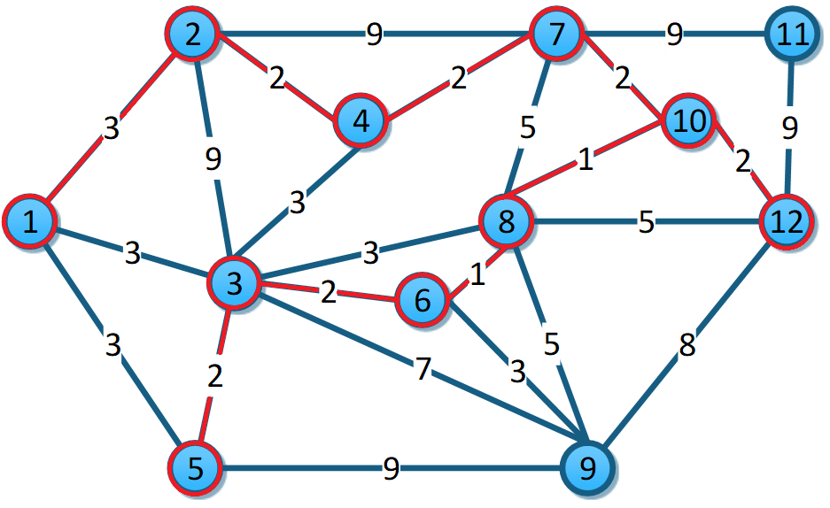

De 12-11, 9=9 es igual. De 12-9, 8>3 no se cambia. Usamos el nodo 9.

|  |  |  |  |  |  |  |  |  |  |  |  |
| --- | --- | --- | --- | --- | --- | --- | --- | --- | --- | --- | --- |
| 1 | 2 | 3 | 4 | 5 | 6 | 7 | 8 | 9 | 10 | 11 | 12 |
| 0 | 3 | 2 | 2 | 2 | 1 | 2 | 1 | 3 | 2 | 9 | 2 |

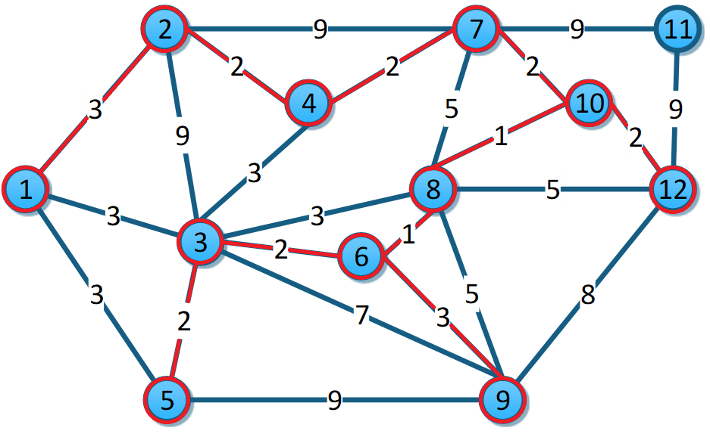

Finalmente se toma 11.

|  |  |  |  |  |  |  |  |  |  |  |  |
| --- | --- | --- | --- | --- | --- | --- | --- | --- | --- | --- | --- |
| 1 | 2 | 3 | 4 | 5 | 6 | 7 | 8 | 9 | 10 | 11 | 12 |
| 0 | 3 | 2 | 2 | 2 | 1 | 2 | 1 | 3 | 2 | 9 | 2 |

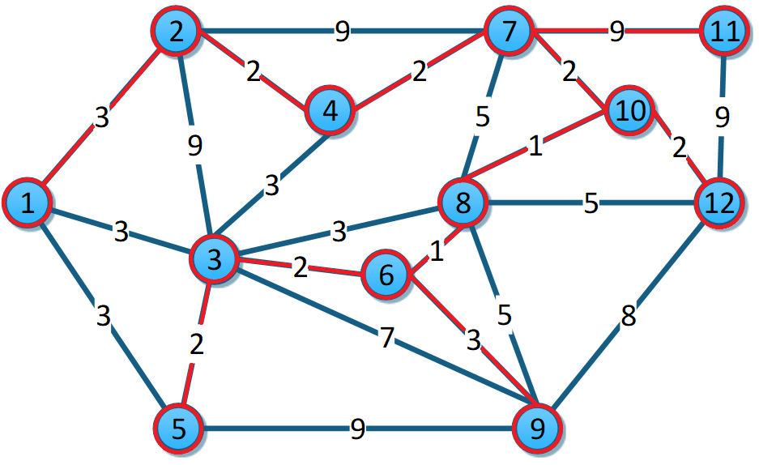

## Kruskal:

Ordenamos aristas por peso de menor a mayor.

|  |  |
| --- | --- |
| 6-8 | 1 |
| 8-10 | 1 |
| 2-4 | 2 |
| 3-5 | 2 |
| 3-6 | 2 |
| 4-7 | 2 |
| 7-10 | 2 |
| 10-12 | 2 |
| 1-2 | 3 |
| 1-3 | 3 |
| 1-5 | 3 |
| 3-4 | 3 |
| 3-8 | 3 |
| 6-9 | 3 |
| 7-8 | 5 |
| 8-9 | 5 |
| 8-12 | 5 |
| 3-9 | 7 |
| 9-12 | 8 |
| 2-3 | 9 |
| 2-7 | 9 |
| 5-9 | 9 |
| 7-11 | 9 |
| 11-12 | 9 |

Tomamos 6-8

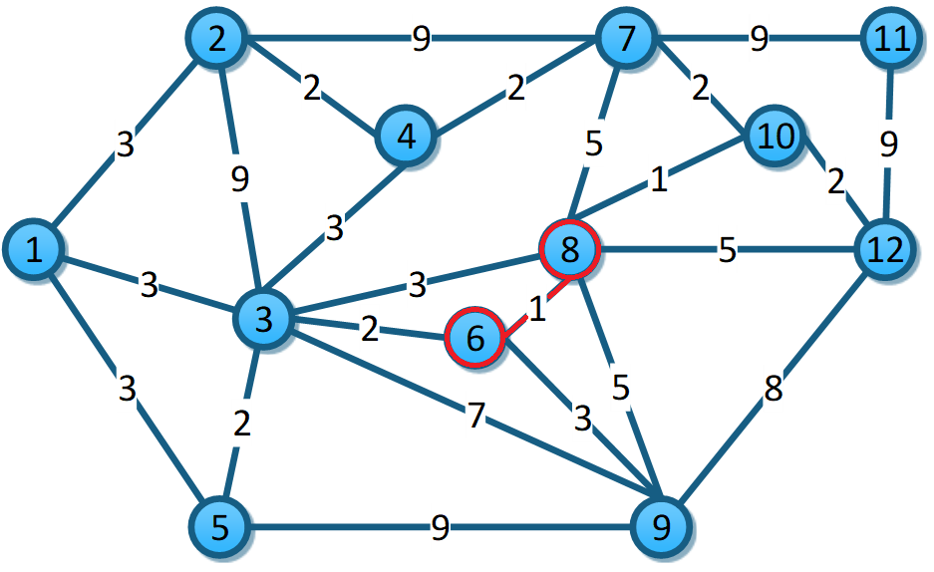

|  |  |
| --- | --- |
| 6-8 | 1 |
| 8-10 | 1 |
| 2-4 | 2 |
| 3-5 | 2 |
| 3-6 | 2 |
| 4-7 | 2 |
| 7-10 | 2 |
| 10-12 | 2 |
| 1-2 | 3 |
| 1-3 | 3 |
| 1-5 | 3 |
| 3-4 | 3 |
| 3-8 | 3 |
| 6-9 | 3 |
| 7-8 | 5 |
| 8-9 | 5 |
| 8-12 | 5 |
| 3-9 | 7 |
| 9-12 | 8 |
| 2-3 | 9 |
| 2-7 | 9 |
| 5-9 | 9 |
| 7-11 | 9 |
| 11-12 | 9 |

Tomamos 8-10.

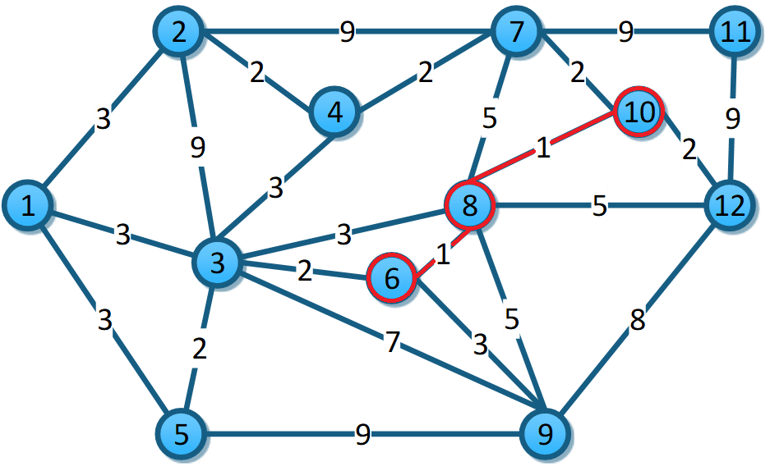

|  |  |
| --- | --- |
| 6-8 | 1 |
| 8-10 | 1 |
| 2-4 | 2 |
| 3-5 | 2 |
| 3-6 | 2 |
| 4-7 | 2 |
| 7-10 | 2 |
| 10-12 | 2 |
| 1-2 | 3 |
| 1-3 | 3 |
| 1-5 | 3 |
| 3-4 | 3 |
| 3-8 | 3 |
| 6-9 | 3 |
| 7-8 | 5 |
| 8-9 | 5 |
| 8-12 | 5 |
| 3-9 | 7 |
| 9-12 | 8 |
| 2-3 | 9 |
| 2-7 | 9 |
| 5-9 | 9 |
| 7-11 | 9 |
| 11-12 | 9 |

Tomamos 2-4.

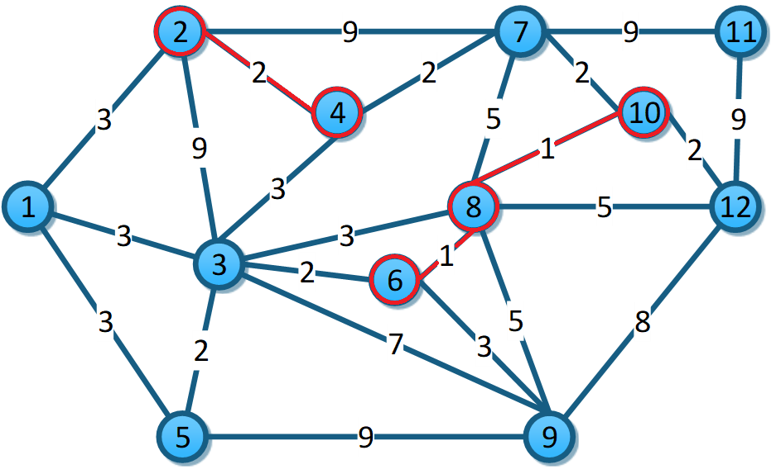

|  |  |
| --- | --- |
| 6-8 | 1 |
| 8-10 | 1 |
| 2-4 | 2 |
| 3-5 | 2 |
| 3-6 | 2 |
| 4-7 | 2 |
| 7-10 | 2 |
| 10-12 | 2 |
| 1-2 | 3 |
| 1-3 | 3 |
| 1-5 | 3 |
| 3-4 | 3 |
| 3-8 | 3 |
| 6-9 | 3 |
| 7-8 | 5 |
| 8-9 | 5 |
| 8-12 | 5 |
| 3-9 | 7 |
| 9-12 | 8 |
| 2-3 | 9 |
| 2-7 | 9 |
| 5-9 | 9 |
| 7-11 | 9 |
| 11-12 | 9 |

Tomamos 3-5.

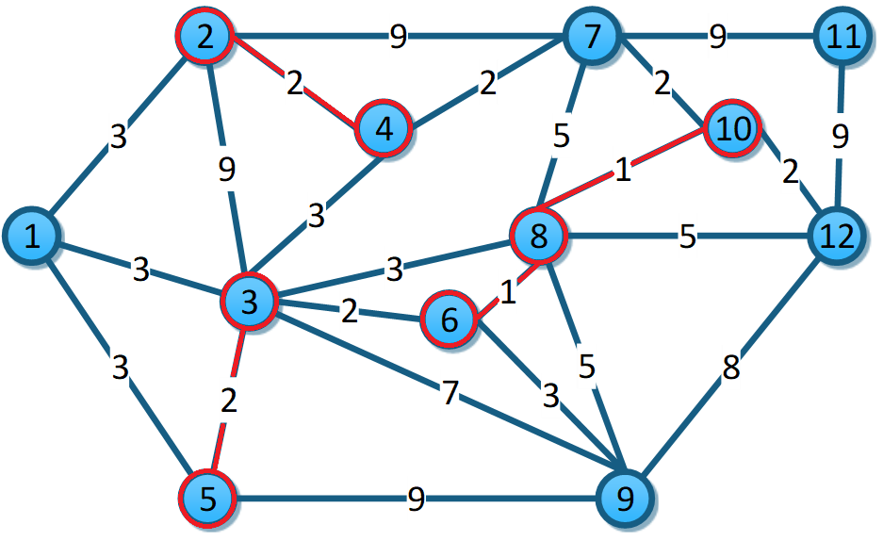

|  |  |
| --- | --- |
| 6-8 | 1 |
| 8-10 | 1 |
| 2-4 | 2 |
| 3-5 | 2 |
| 3-6 | 2 |
| 4-7 | 2 |
| 7-10 | 2 |
| 10-12 | 2 |
| 1-2 | 3 |
| 1-3 | 3 |
| 1-5 | 3 |
| 3-4 | 3 |
| 3-8 | 3 |
| 6-9 | 3 |
| 7-8 | 5 |
| 8-9 | 5 |
| 8-12 | 5 |
| 3-9 | 7 |
| 9-12 | 8 |
| 2-3 | 9 |
| 2-7 | 9 |
| 5-9 | 9 |
| 7-11 | 9 |
| 11-12 | 9 |

Tomamos 3-6.

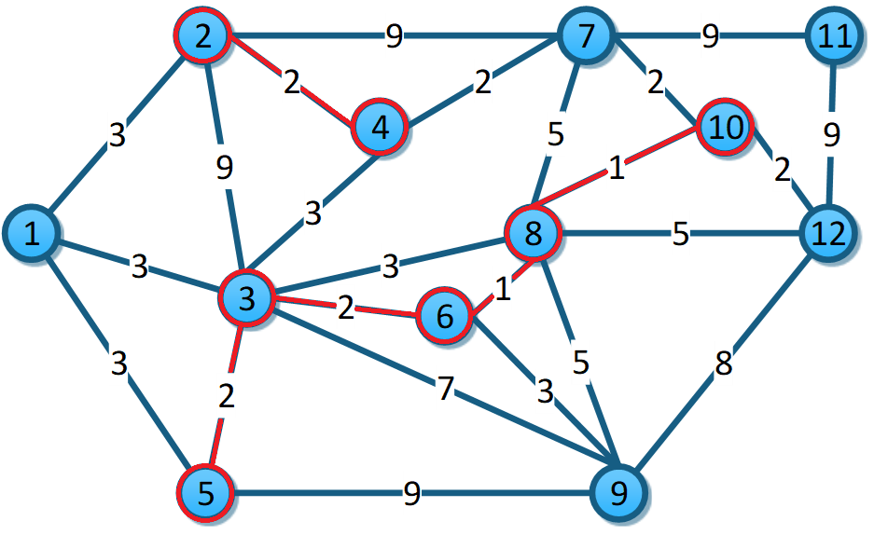

|  |  |
| --- | --- |
| 6-8 | 1 |
| 8-10 | 1 |
| 2-4 | 2 |
| 3-5 | 2 |
| 3-6 | 2 |
| 4-7 | 2 |
| 7-10 | 2 |
| 10-12 | 2 |
| 1-2 | 3 |
| 1-3 | 3 |
| 1-5 | 3 |
| 3-4 | 3 |
| 3-8 | 3 |
| 6-9 | 3 |
| 7-8 | 5 |
| 8-9 | 5 |
| 8-12 | 5 |
| 3-9 | 7 |
| 9-12 | 8 |
| 2-3 | 9 |
| 2-7 | 9 |
| 5-9 | 9 |
| 7-11 | 9 |
| 11-12 | 9 |

Tomamos 4-7.

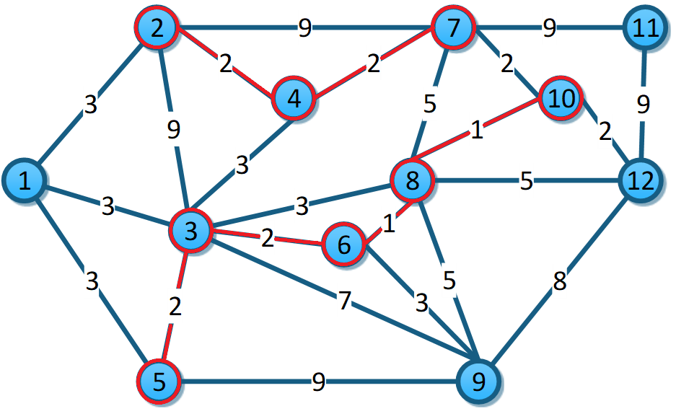

|  |  |
| --- | --- |
| 6-8 | 1 |
| 8-10 | 1 |
| 2-4 | 2 |
| 3-5 | 2 |
| 3-6 | 2 |
| 4-7 | 2 |
| 7-10 | 2 |
| 10-12 | 2 |
| 1-2 | 3 |
| 1-3 | 3 |
| 1-5 | 3 |
| 3-4 | 3 |
| 3-8 | 3 |
| 6-9 | 3 |
| 7-8 | 5 |
| 8-9 | 5 |
| 8-12 | 5 |
| 3-9 | 7 |
| 9-12 | 8 |
| 2-3 | 9 |
| 2-7 | 9 |
| 5-9 | 9 |
| 7-11 | 9 |
| 11-12 | 9 |

Tomamos 7-10.

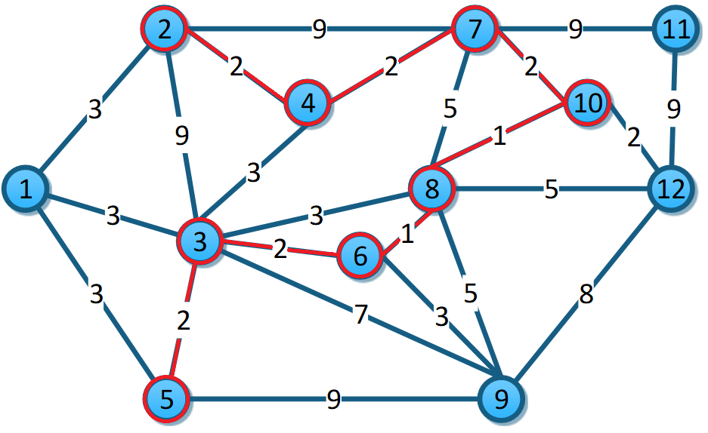

|  |  |
| --- | --- |
| 6-8 | 1 |
| 8-10 | 1 |
| 2-4 | 2 |
| 3-5 | 2 |
| 3-6 | 2 |
| 4-7 | 2 |
| 7-10 | 2 |
| 10-12 | 2 |
| 1-2 | 3 |
| 1-3 | 3 |
| 1-5 | 3 |
| 3-4 | 3 |
| 3-8 | 3 |
| 6-9 | 3 |
| 7-8 | 5 |
| 8-9 | 5 |
| 8-12 | 5 |
| 3-9 | 7 |
| 9-12 | 8 |
| 2-3 | 9 |
| 2-7 | 9 |
| 5-9 | 9 |
| 7-11 | 9 |
| 11-12 | 9 |

Tomamos 10-12.

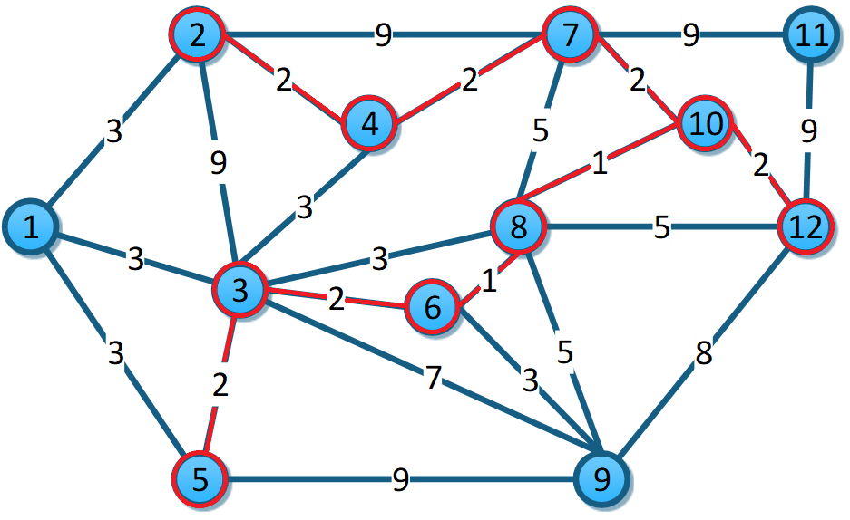

|  |  |
| --- | --- |
| 6-8 | 1 |
| 8-10 | 1 |
| 2-4 | 2 |
| 3-5 | 2 |
| 3-6 | 2 |
| 4-7 | 2 |
| 7-10 | 2 |
| 10-12 | 2 |
| 1-2 | 3 |
| 1-3 | 3 |
| 1-5 | 3 |
| 3-4 | 3 |
| 3-8 | 3 |
| 6-9 | 3 |
| 7-8 | 5 |
| 8-9 | 5 |
| 8-12 | 5 |
| 3-9 | 7 |
| 9-12 | 8 |
| 2-3 | 9 |
| 2-7 | 9 |
| 5-9 | 9 |
| 7-11 | 9 |
| 11-12 | 9 |

Tomamos 1-2.

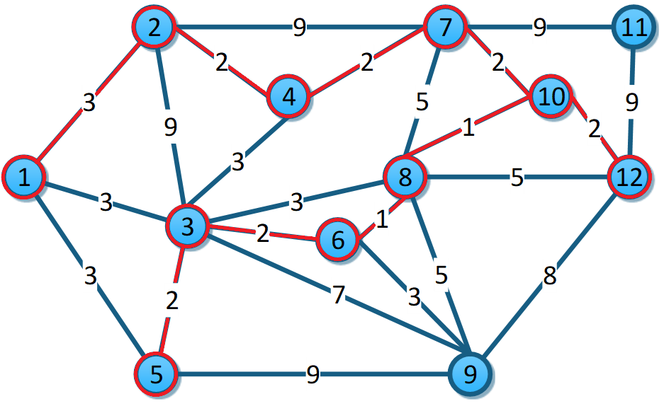

|  |  |
| --- | --- |
| 6-8 | 1 |
| 8-10 | 1 |
| 2-4 | 2 |
| 3-5 | 2 |
| 3-6 | 2 |
| 4-7 | 2 |
| 7-10 | 2 |
| 10-12 | 2 |
| 1-2 | 3 |
| 1-3 | 3 |
| 1-5 | 3 |
| 3-4 | 3 |
| 3-8 | 3 |
| 6-9 | 3 |
| 7-8 | 5 |
| 8-9 | 5 |
| 8-12 | 5 |
| 3-9 | 7 |
| 9-12 | 8 |
| 2-3 | 9 |
| 2-7 | 9 |
| 5-9 | 9 |
| 7-11 | 9 |
| 11-12 | 9 |

De 1-3 a 3-8 forman ciclos así que tomamos 6-9.

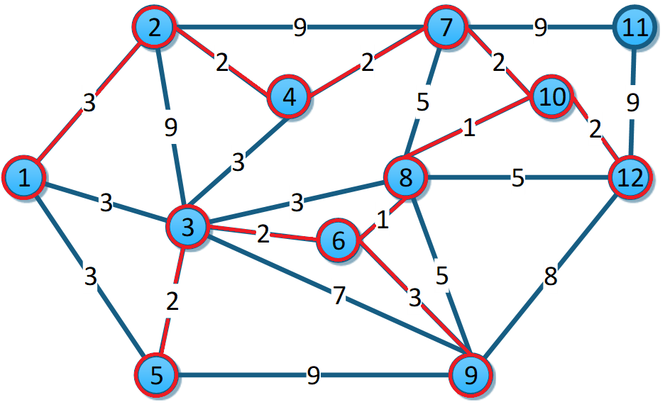

|  |  |
| --- | --- |
| 6-8 | 1 |
| 8-10 | 1 |
| 2-4 | 2 |
| 3-5 | 2 |
| 3-6 | 2 |
| 4-7 | 2 |
| 7-10 | 2 |
| 10-12 | 2 |
| 1-2 | 3 |
| ~~1-3~~ | ~~3~~ |
| ~~1-5~~ | ~~3~~ |
| ~~3-4~~ | ~~3~~ |
| ~~3-8~~ | ~~3~~ |
| 6-9 | 3 |
| 7-8 | 5 |
| 8-9 | 5 |
| 8-12 | 5 |
| 3-9 | 7 |
| 9-12 | 8 |
| 2-3 | 9 |
| 2-7 | 9 |
| 5-9 | 9 |
| 7-11 | 9 |
| 11-12 | 9 |

De 7-8 a 5-9 generan ciclos. Tomamos 7-11 y ya es el último nodo.

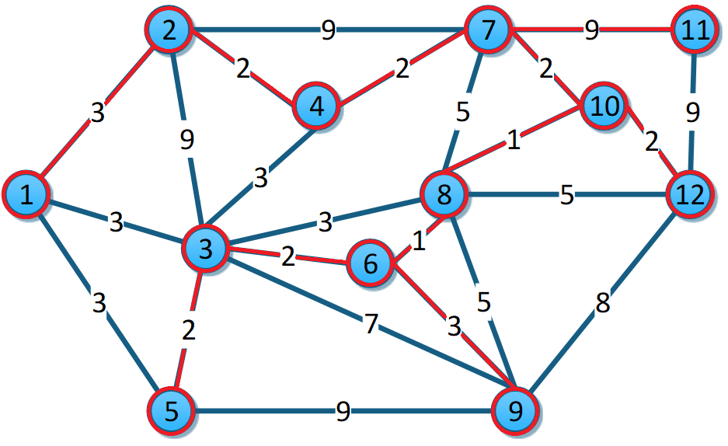

|  |  |
| --- | --- |
| 6-8 | 1 |
| 8-10 | 1 |
| 2-4 | 2 |
| 3-5 | 2 |
| 3-6 | 2 |
| 4-7 | 2 |
| 7-10 | 2 |
| 10-12 | 2 |
| 1-2 | 3 |
| ~~1-3~~ | ~~3~~ |
| ~~1-5~~ | ~~3~~ |
| ~~3-4~~ | ~~3~~ |
| ~~3-8~~ | ~~3~~ |
| 6-9 | 3 |
| ~~7-8~~ | ~~5~~ |
| ~~8-9~~ | ~~5~~ |
| ~~8-12~~ | ~~5~~ |
| ~~3-9~~ | ~~7~~ |
| ~~9-12~~ | ~~8~~ |
| ~~2-3~~ | ~~9~~ |
| ~~2-7~~ | ~~9~~ |
| ~~5-9~~ | ~~9~~ |
| 7-11 | 9 |
| 11-12 | 9 |

## Dijkstra:

Camino más corto de 1 a 12.

|  |  |  |  |  |  |  |
| --- | --- | --- | --- | --- | --- | --- |
| Vértices |  |  |  |  |  |  |
| 1 | (0,1) | * | * | * | * | * |
| 2 | (3,1) | (12,3) | ∞ |  |  |  |
| 3 | (3,1)-> | (3,1) | * | * | * | * |
| 4 | ∞ | (6,3) | ∞ | ∞ |  |  |
| 5 | (3,1) | (5,3) | ∞ | ∞ |  |  |
| 6 | ∞ | (5,3)-> | (5,3) | * | * | * |
| 7 | ∞ | ∞ | ∞ | (11,8) | (9,10) |  |
| 8 | ∞ | (6,3) | (6,6)-> | (6,6) | * | * |
| 9 | ∞ | (10,3) | (8,6) | (11,8) | ∞ | * |
| 10 | ∞ | ∞ | ∞ | (7,8)-> | (7,8) | * |
| 11 | ∞ | ∞ | ∞ | ∞ | ∞ | * |
| 12 | ∞ | ∞ | ∞ | (11,8) | (9,10)-> | (9,10) |

# **Ejercicio 4:**

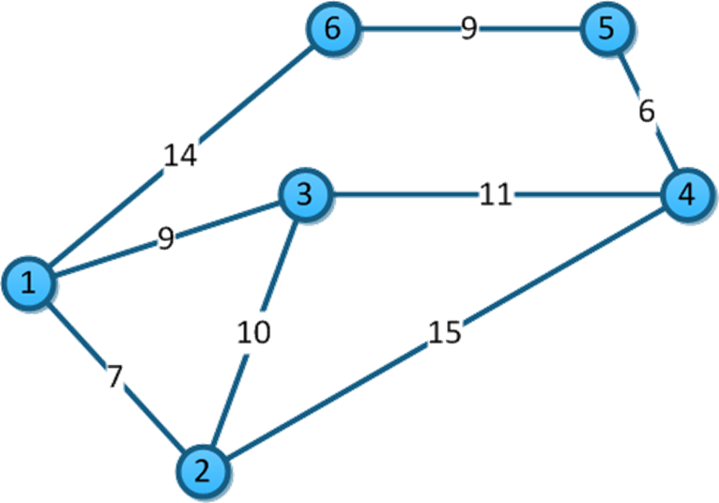

## Prim:

Iniciamos en 1. Llenamos todos con infinito menos el 1 ya que ya estamos ahí.

|  |  |  |  |  |  |
| --- | --- | --- | --- | --- | --- |
| 1 | 2 | 3 | 4 | 5 | 6 |
| 0 | ∞ | ∞ | ∞ | ∞ | ∞ |

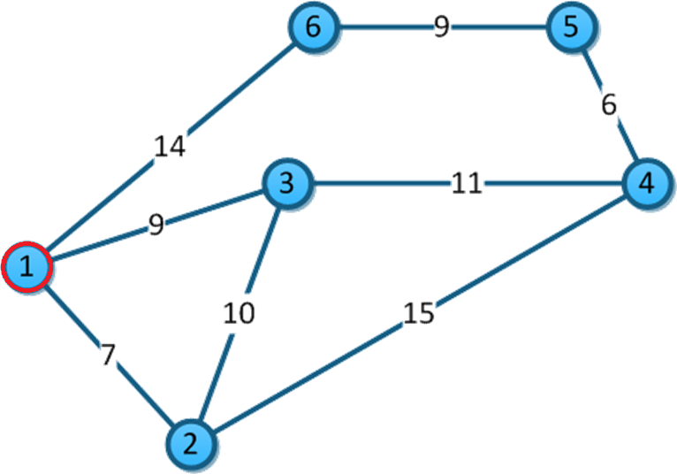

De 1-2, 7<∞ se cambia. De 1-3 9<∞ se cambia. 1-6 14<∞ se cambia. Tomamos el nodo 2.

|  |  |  |  |  |  |
| --- | --- | --- | --- | --- | --- |
| 1 | 2 | 3 | 4 | 5 | 6 |
| 0 | 7 | 9 | ∞ | ∞ | 14 |

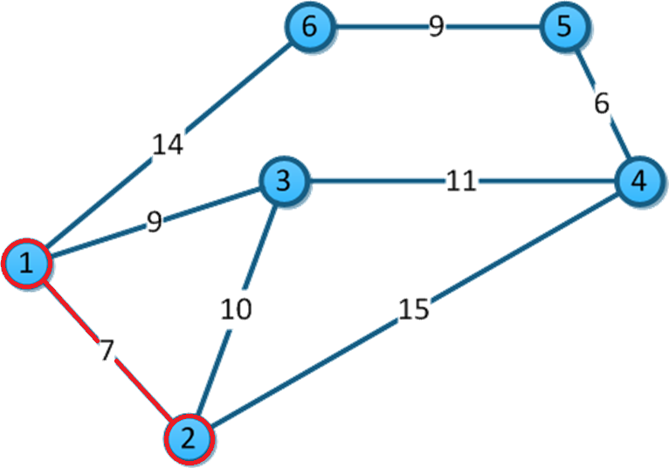

De 2-3, 10>9 no se cambia. De 2-4, 15<∞ se cambia. Tomamos el nodo 3.

|  |  |  |  |  |  |
| --- | --- | --- | --- | --- | --- |
| 1 | 2 | 3 | 4 | 5 | 6 |
| 0 | 7 | 9 | ∞ | 15 | 14 |

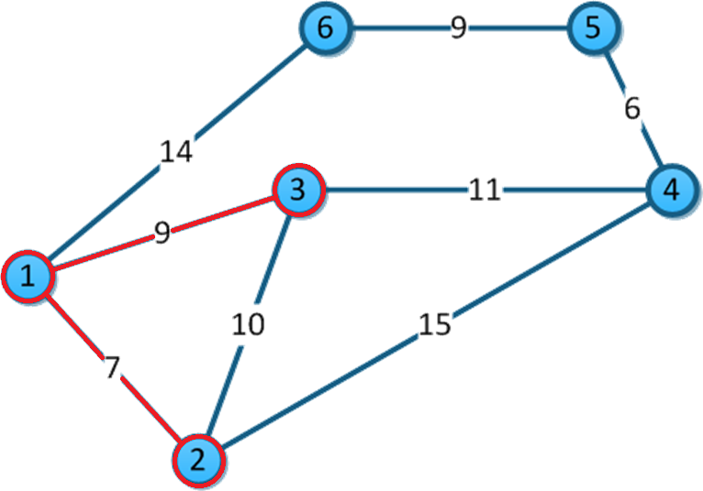

De 3-4, 11<∞ se cambia. Tomamos al nodo 4.

|  |  |  |  |  |  |
| --- | --- | --- | --- | --- | --- |
| 1 | 2 | 3 | 4 | 5 | 6 |
| 0 | 7 | 9 | 11 | 15 | 14 |

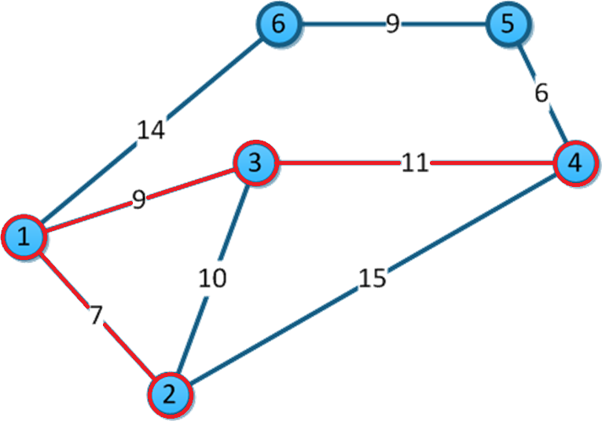

De 4-5, 6<15 se cambia. Vamos al nodo 5.

|  |  |  |  |  |  |
| --- | --- | --- | --- | --- | --- |
| 1 | 2 | 3 | 4 | 5 | 6 |
| 0 | 7 | 9 | 11 | 6 | 14 |

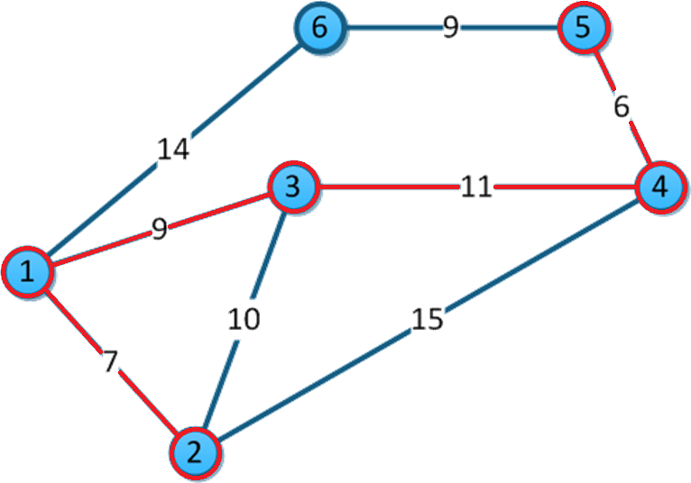

De 5-6, 9<14 se cambia. Tomamos el último nodo.

|  |  |  |  |  |  |
| --- | --- | --- | --- | --- | --- |
| 1 | 2 | 3 | 4 | 5 | 6 |
| 0 | 7 | 9 | 11 | 6 | 9 |

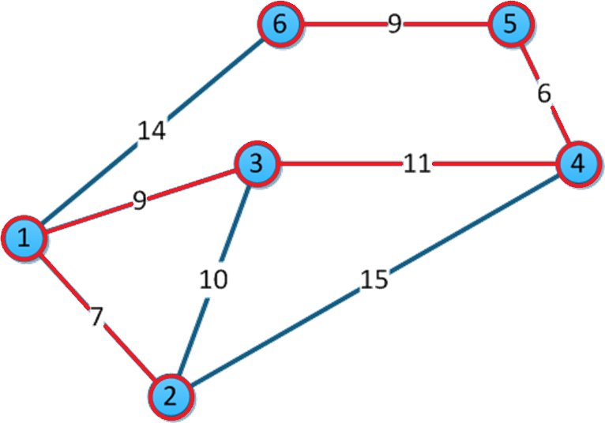

## Kruskal:

Ordenamos por peso las aristas.

|  |  |
| --- | --- |
| 4-5 | 6 |
| 1-2 | 7 |
| 1-3 | 9 |
| 5-6 | 9 |
| 2-3 | 10 |
| 3-4 | 11 |
| 1-6 | 14 |
| 2-4 | 15 |

Tomamos 4-5.

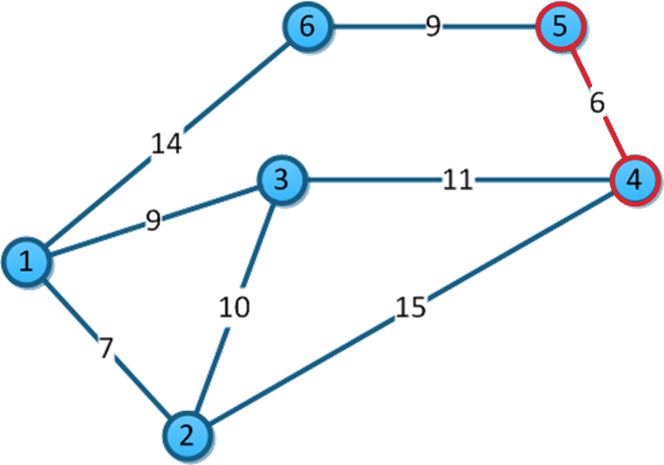

|  |  |
| --- | --- |
| 4-5 | 6 |
| 1-2 | 7 |
| 1-3 | 9 |
| 5-6 | 9 |
| 2-3 | 10 |
| 3-4 | 11 |
| 1-6 | 14 |
| 2-4 | 15 |

Tomamos 1-2.

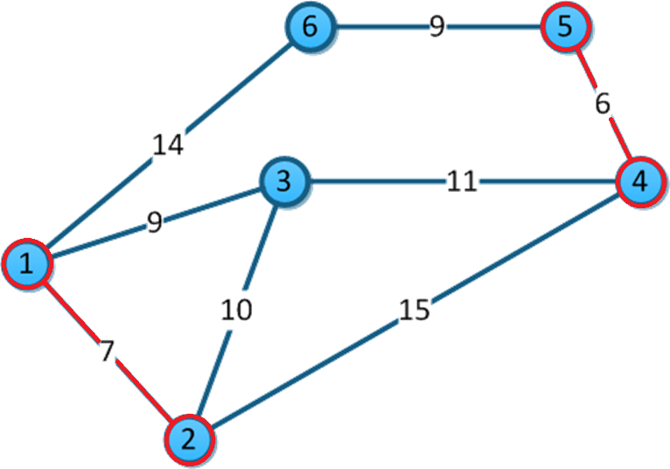

|  |  |
| --- | --- |
| 4-5 | 6 |
| 1-2 | 7 |
| 1-3 | 9 |
| 5-6 | 9 |
| 2-3 | 10 |
| 3-4 | 11 |
| 1-6 | 14 |
| 2-4 | 15 |

Tomamos 1-3.

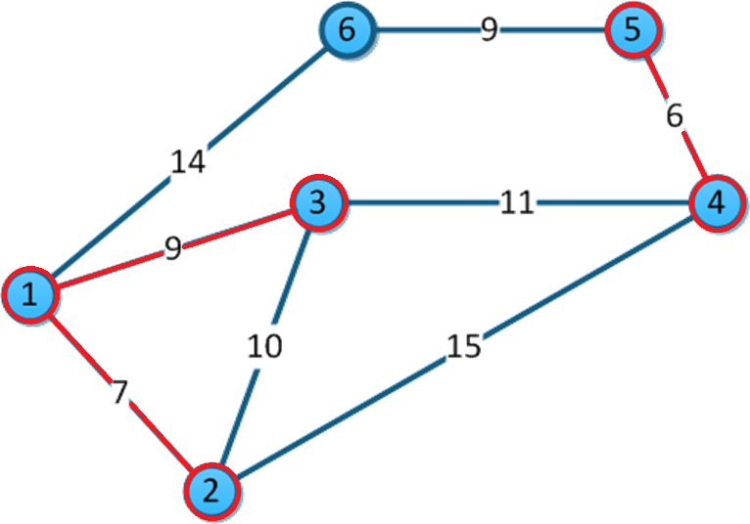

|  |  |
| --- | --- |
| 4-5 | 6 |
| 1-2 | 7 |
| 1-3 | 9 |
| 5-6 | 9 |
| 2-3 | 10 |
| 3-4 | 11 |
| 1-6 | 14 |
| 2-4 | 15 |

Tomamos 5-6.

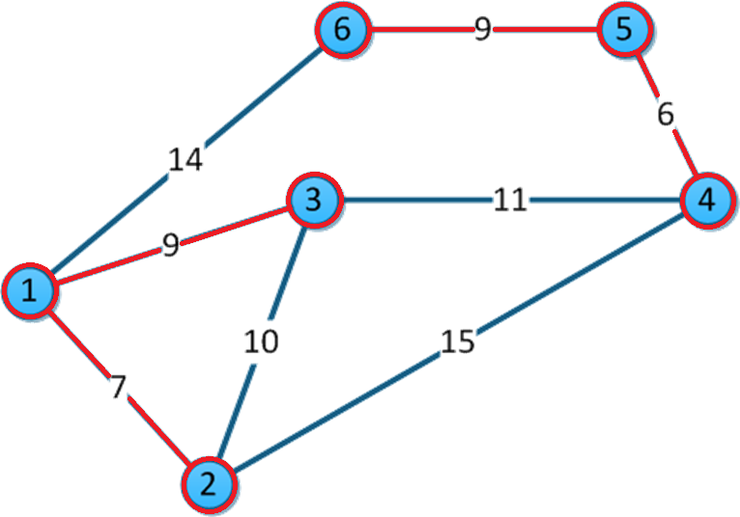

|  |  |
| --- | --- |
| 4-5 | 6 |
| 1-2 | 7 |
| 1-3 | 9 |
| 5-6 | 9 |
| 2-3 | 10 |
| 3-4 | 11 |
| 1-6 | 14 |
| 2-4 | 15 |

2-3 forma un ciclo. Tomamos 3-4 y ya es la última arista.

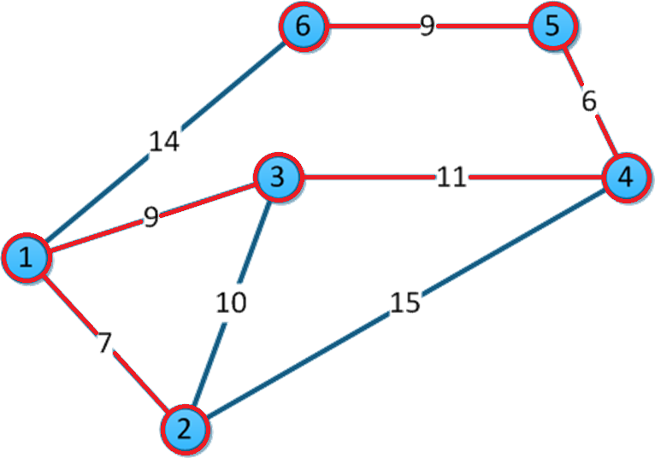

|  |  |
| --- | --- |
| 4-5 | 6 |
| 1-2 | 7 |
| 1-3 | 9 |
| 5-6 | 9 |
| ~~2-3~~ | ~~10~~ |
| 3-4 | 11 |
| 1-6 | 14 |
| 2-4 | 15 |

## Dijkstra:

Camino de 1 a 4.

|  |  |  |  |
| --- | --- | --- | --- |
| Vértice |  |  |  |
| 1 | (0,1) | * | * |
| 2 | (7,1) | (19,3) | * |
| 3 | (9,1)-> | (9,1) | * |
| 4 | ∞ | (20,3)-> | (20,3) |
| 5 | ∞ | ∞ | * |
| 6 | (14,1) | ∞ | * |

# **Ejercicio 5:**

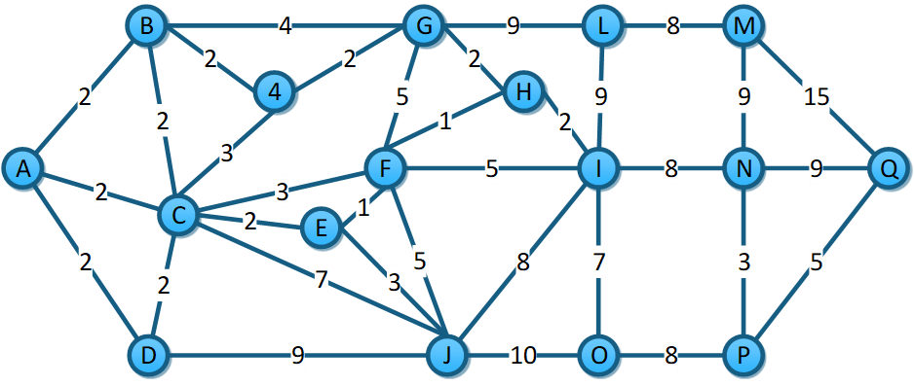

## Prim:

Les asignamos a todos el valor de infinito menos a A que será nuestro punto de inicio

|  |  |  |  |  |  |  |  |  |  |  |  |  |  |  |  |  |
| --- | --- | --- | --- | --- | --- | --- | --- | --- | --- | --- | --- | --- | --- | --- | --- | --- |
| A | B | C | D | E | F | G | H | I | J | 4 | L | M | N | O | P | Q |
| 0 | ∞ | ∞ | ∞ | ∞ | ∞ | ∞ | ∞ | ∞ | ∞ | ∞ | ∞ | ∞ | ∞ | ∞ | ∞ | ∞ |

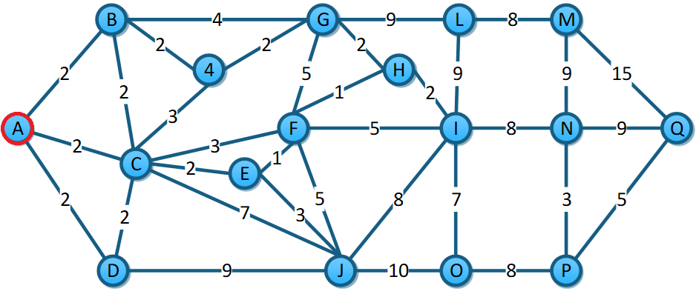

De A-B, 2<∞ se cambia. De A-C, 2<∞ se cambia. De A-D, 2<∞ se cambia. Vamos a B.

|  |  |  |  |  |  |  |  |  |  |  |  |  |  |  |  |  |
| --- | --- | --- | --- | --- | --- | --- | --- | --- | --- | --- | --- | --- | --- | --- | --- | --- |
| A | B | C | D | E | F | G | H | I | J | 4 | L | M | N | O | P | Q |
| 0 | 2 | 2 | 2 | ∞ | ∞ | ∞ | ∞ | ∞ | ∞ | ∞ | ∞ | ∞ | ∞ | ∞ | ∞ | ∞ |

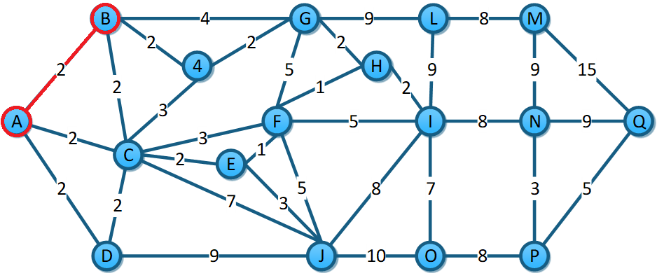

De B-C, 2=2 es igual. De B-G, 4<∞ se cambia. De B-4, 2<∞ se cambia. Vamos a nodo 4.

|  |  |  |  |  |  |  |  |  |  |  |  |  |  |  |  |  |
| --- | --- | --- | --- | --- | --- | --- | --- | --- | --- | --- | --- | --- | --- | --- | --- | --- |
| A | B | C | D | E | F | G | H | I | J | 4 | L | M | N | O | P | Q |
| 0 | 2 | 2 | 2 | ∞ | ∞ | 4 | ∞ | ∞ | ∞ | 2 | ∞ | ∞ | ∞ | ∞ | ∞ | ∞ |

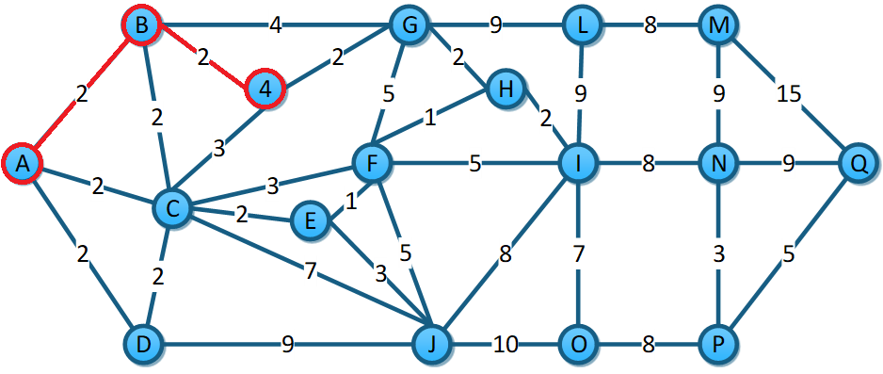

De 4-G, 2<4 se cambia. De 4-C, 3>2 no se cambia. Nos movemos a G.

|  |  |  |  |  |  |  |  |  |  |  |  |  |  |  |  |  |
| --- | --- | --- | --- | --- | --- | --- | --- | --- | --- | --- | --- | --- | --- | --- | --- | --- |
| A | B | C | D | E | F | G | H | I | J | 4 | L | M | N | O | P | Q |
| 0 | 2 | 2 | 2 | ∞ | ∞ | 2 | ∞ | ∞ | ∞ | 2 | ∞ | ∞ | ∞ | ∞ | ∞ | ∞ |

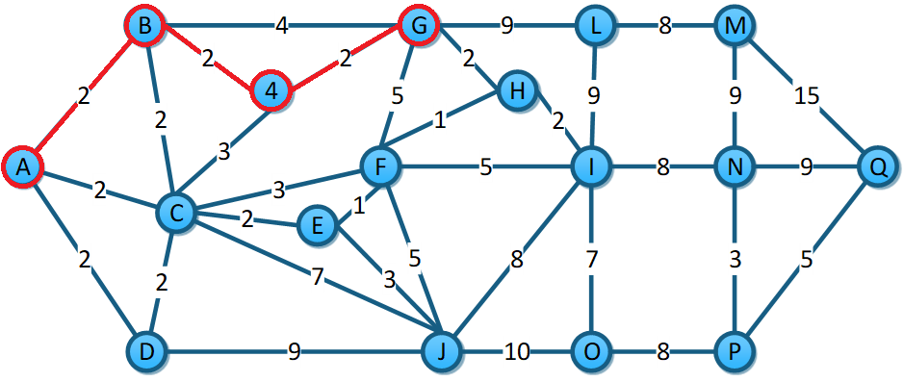

De G-F, 5<∞ se cambia. De G-H, 2<∞ se cambia. De G-L, 9<∞ se cambia. Tomemos C.

|  |  |  |  |  |  |  |  |  |  |  |  |  |  |  |  |  |
| --- | --- | --- | --- | --- | --- | --- | --- | --- | --- | --- | --- | --- | --- | --- | --- | --- |
| A | B | C | D | E | F | G | H | I | J | 4 | L | M | N | O | P | Q |
| 0 | 2 | 2 | 2 | ∞ | 5 | 2 | 2 | ∞ | ∞ | 2 | 9 | ∞ | ∞ | ∞ | ∞ | ∞ |

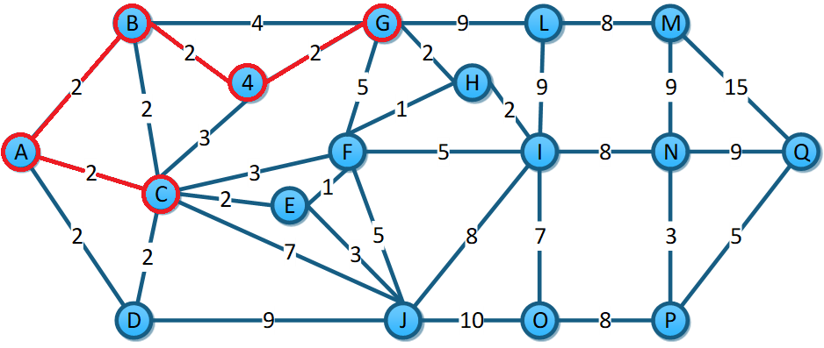

De C-E, 2<∞ se cambia. De C-J, 7<∞ se cambia. De C-F, 3<5 se cambia. De C-D, 2=2 es igual. Nos movemos a D.

|  |  |  |  |  |  |  |  |  |  |  |  |  |  |  |  |  |
| --- | --- | --- | --- | --- | --- | --- | --- | --- | --- | --- | --- | --- | --- | --- | --- | --- |
| A | B | C | D | E | F | G | H | I | J | 4 | L | M | N | O | P | Q |
| 0 | 2 | 2 | 2 | 2 | 3 | 2 | 2 | ∞ | 7 | 2 | 9 | ∞ | ∞ | ∞ | ∞ | ∞ |

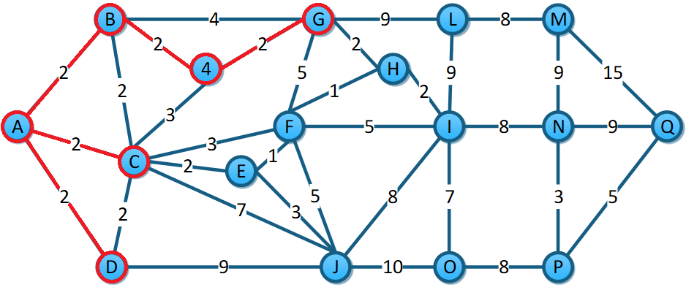

De D-J, 9>7 no se cambia. Nos movemos a E.

|  |  |  |  |  |  |  |  |  |  |  |  |  |  |  |  |  |
| --- | --- | --- | --- | --- | --- | --- | --- | --- | --- | --- | --- | --- | --- | --- | --- | --- |
| A | B | C | D | E | F | G | H | I | J | 4 | L | M | N | O | P | Q |
| 0 | 2 | 2 | 2 | 2 | 3 | 2 | 2 | ∞ | 7 | 2 | 9 | ∞ | ∞ | ∞ | ∞ | ∞ |

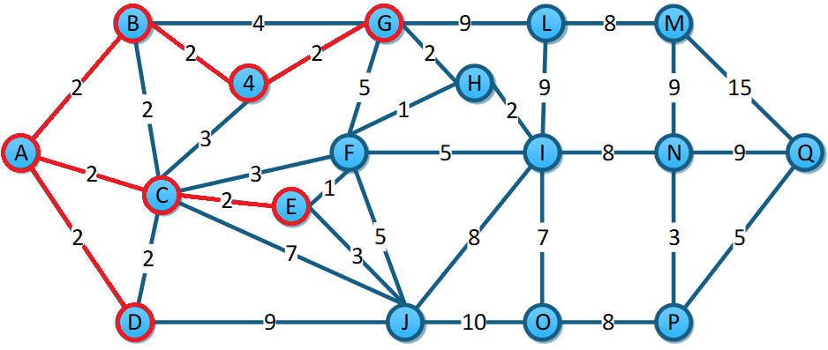

De E-F, 1<3 se cambia. De E-J, 3<7 se cambia. Nos movemos a F.

|  |  |  |  |  |  |  |  |  |  |  |  |  |  |  |  |  |
| --- | --- | --- | --- | --- | --- | --- | --- | --- | --- | --- | --- | --- | --- | --- | --- | --- |
| A | B | C | D | E | F | G | H | I | J | 4 | L | M | N | O | P | Q |
| 0 | 2 | 2 | 2 | 2 | 1 | 2 | 2 | ∞ | 3 | 2 | 9 | ∞ | ∞ | ∞ | ∞ | ∞ |

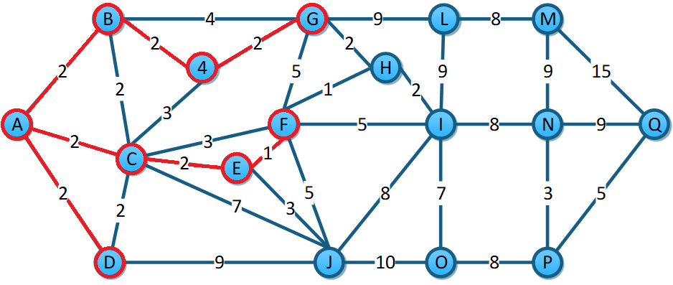

De F-H, 1<2 se cambia. De F-I, 5<∞ se cambia. De F-J, 5>3 no se cambia. Vamos a H.

|  |  |  |  |  |  |  |  |  |  |  |  |  |  |  |  |  |
| --- | --- | --- | --- | --- | --- | --- | --- | --- | --- | --- | --- | --- | --- | --- | --- | --- |
| A | B | C | D | E | F | G | H | I | J | 4 | L | M | N | O | P | Q |
| 0 | 2 | 2 | 2 | 2 | 1 | 2 | 1 | 5 | 3 | 2 | 9 | ∞ | ∞ | ∞ | ∞ | ∞ |

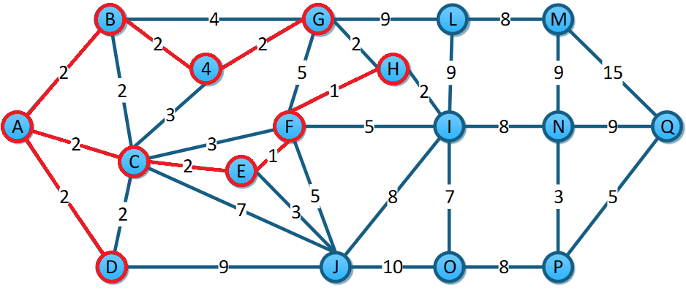

De H-I, 2<g se cambia. Nos movemos a I.

|  |  |  |  |  |  |  |  |  |  |  |  |  |  |  |  |  |
| --- | --- | --- | --- | --- | --- | --- | --- | --- | --- | --- | --- | --- | --- | --- | --- | --- |
| A | B | C | D | E | F | G | H | I | J | 4 | L | M | N | O | P | Q |
| 0 | 2 | 2 | 2 | 2 | 1 | 2 | 1 | 2 | 3 | 2 | 9 | ∞ | ∞ | ∞ | ∞ | ∞ |

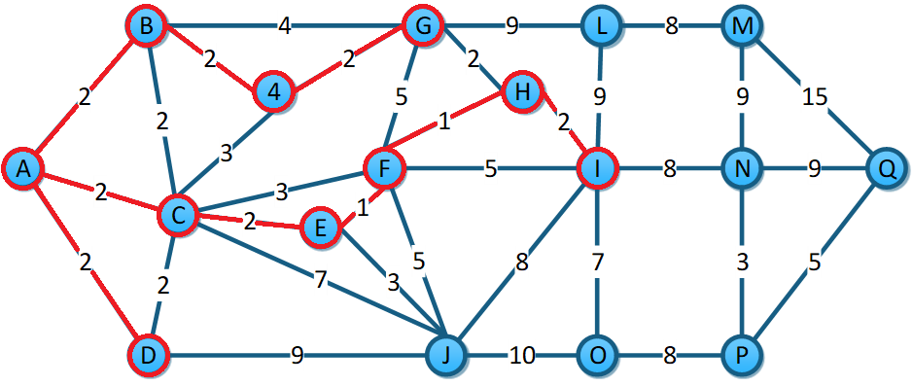

De I-J, 8>3 no se cambia. De I-L, 9=9 da igual. De I-O, 7<∞ se cambia. De I-N 8<∞ se cambia. Nos movemos a J.

|  |  |  |  |  |  |  |  |  |  |  |  |  |  |  |  |  |
| --- | --- | --- | --- | --- | --- | --- | --- | --- | --- | --- | --- | --- | --- | --- | --- | --- |
| A | B | C | D | E | F | G | H | I | J | 4 | L | M | N | O | P | Q |
| 0 | 2 | 2 | 2 | 2 | 1 | 2 | 1 | 2 | 3 | 2 | 9 | ∞ | 8 | 7 | ∞ | ∞ |

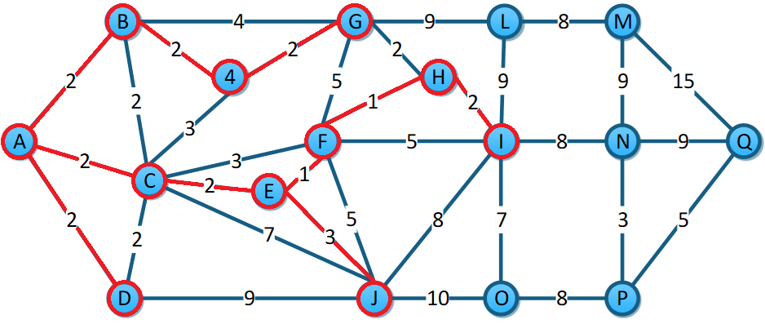

De J-O, 10>7 no se cambia. Nos movemos a O.

|  |  |  |  |  |  |  |  |  |  |  |  |  |  |  |  |  |
| --- | --- | --- | --- | --- | --- | --- | --- | --- | --- | --- | --- | --- | --- | --- | --- | --- |
| A | B | C | D | E | F | G | H | I | J | 4 | L | M | N | O | P | Q |
| 0 | 2 | 2 | 2 | 2 | 1 | 2 | 1 | 2 | 3 | 2 | 9 | ∞ | 8 | 7 | ∞ | ∞ |

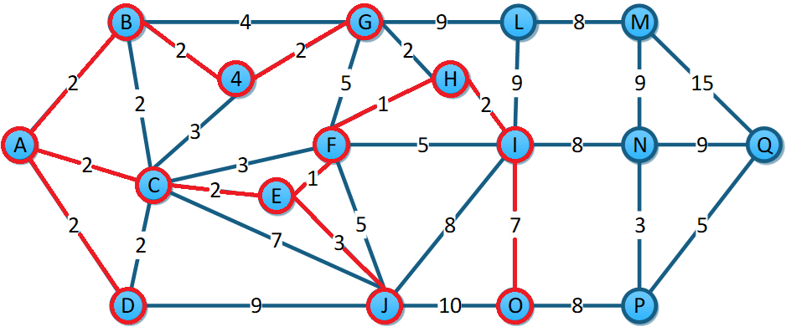

De O-P, 8<∞ se cambia. Nos movemos a N.

|  |  |  |  |  |  |  |  |  |  |  |  |  |  |  |  |  |
| --- | --- | --- | --- | --- | --- | --- | --- | --- | --- | --- | --- | --- | --- | --- | --- | --- |
| A | B | C | D | E | F | G | H | I | J | 4 | L | M | N | O | P | Q |
| 0 | 2 | 2 | 2 | 2 | 1 | 2 | 1 | 2 | 3 | 2 | 9 | ∞ | 8 | 7 | 8 | ∞ |

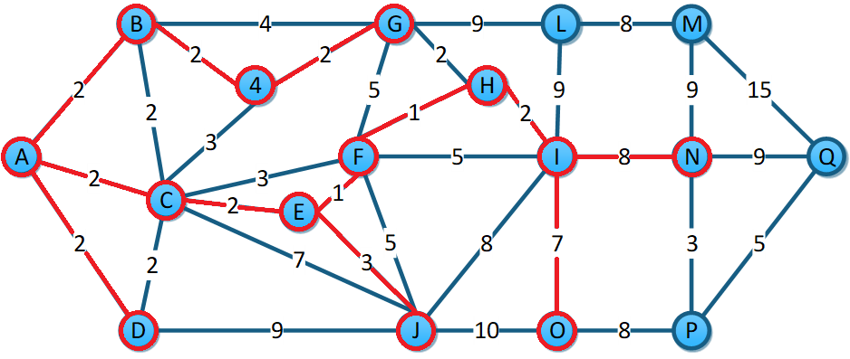

De N-P, 3<8 se cambia. De N-M 9<∞ se cambia. De N-Q, 9<∞ se cambia. Nos movemos a P.

|  |  |  |  |  |  |  |  |  |  |  |  |  |  |  |  |  |
| --- | --- | --- | --- | --- | --- | --- | --- | --- | --- | --- | --- | --- | --- | --- | --- | --- |
| A | B | C | D | E | F | G | H | I | J | 4 | L | M | N | O | P | Q |
| 0 | 2 | 2 | 2 | 2 | 1 | 2 | 1 | 2 | 3 | 2 | 9 | 9 | 8 | 7 | 3 | 9 |

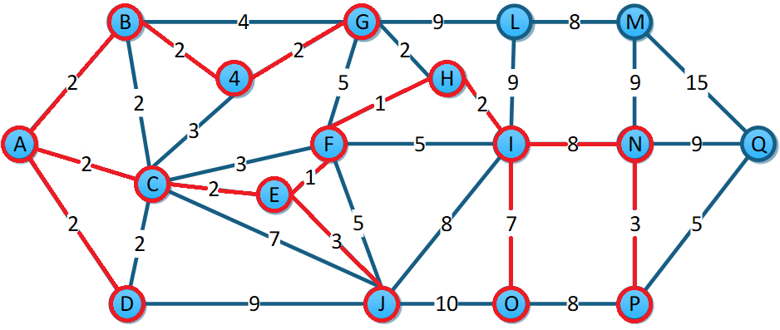

De P-Q, 5<9 se cambia. Nos movemos a Q.

|  |  |  |  |  |  |  |  |  |  |  |  |  |  |  |  |  |
| --- | --- | --- | --- | --- | --- | --- | --- | --- | --- | --- | --- | --- | --- | --- | --- | --- |
| A | B | C | D | E | F | G | H | I | J | 4 | L | M | N | O | P | Q |
| 0 | 2 | 2 | 2 | 2 | 1 | 2 | 1 | 2 | 3 | 2 | 9 | 9 | 8 | 7 | 3 | 5 |

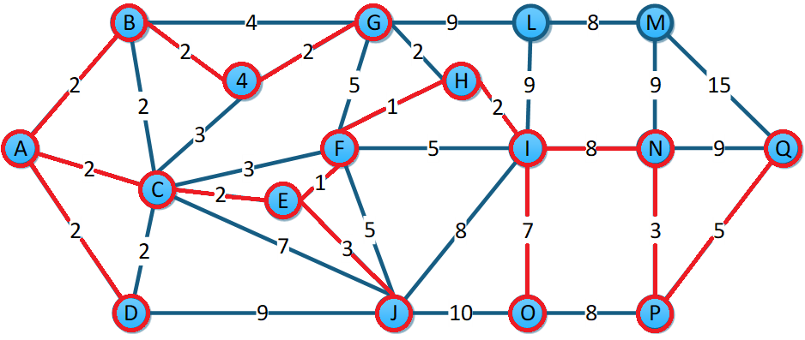

De Q-M, 15>9 no se cambia. Nos movemos a M.

|  |  |  |  |  |  |  |  |  |  |  |  |  |  |  |  |  |
| --- | --- | --- | --- | --- | --- | --- | --- | --- | --- | --- | --- | --- | --- | --- | --- | --- |
| A | B | C | D | E | F | G | H | I | J | 4 | L | M | N | O | P | Q |
| 0 | 2 | 2 | 2 | 2 | 1 | 2 | 1 | 2 | 3 | 2 | 9 | 9 | 8 | 7 | 3 | 5 |

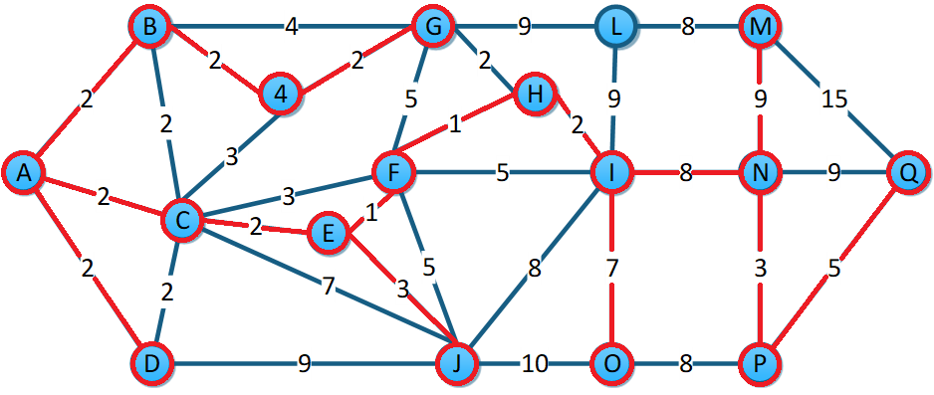

De M-L, 8<9 se cambia y se toma el ultimo nodo.

|  |  |  |  |  |  |  |  |  |  |  |  |  |  |  |  |  |
| --- | --- | --- | --- | --- | --- | --- | --- | --- | --- | --- | --- | --- | --- | --- | --- | --- |
| A | B | C | D | E | F | G | H | I | J | 4 | L | M | N | O | P | Q |
| 0 | 2 | 2 | 2 | 2 | 1 | 2 | 1 | 2 | 3 | 2 | 8 | 9 | 8 | 7 | 3 | 5 |

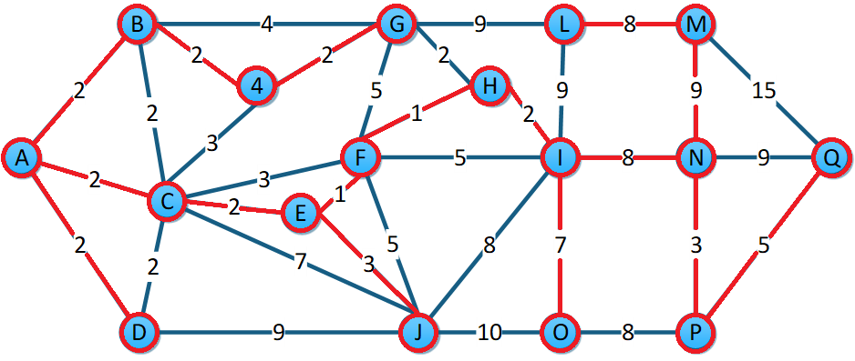

## Kruskal:

|  |  |
| --- | --- |
| E-F | 1 |
| F-H | 1 |
| A-B | 2 |
| A-C | 2 |
| A-D | 2 |
| B-C | 2 |
| C-D | 2 |
| B-4 | 2 |
| 4-G | 2 |
| C-E | 2 |
| G-H | 2 |
| H-I | 2 |
| C-4 | 3 |
| E-J | 3 |
| C-F | 3 |
| N-P | 3 |
| B-G | 4 |
| F-G | 5 |
| F-J | 5 |
| F-I | 5 |
| P-Q | 5 |
| C-J | 7 |
| I-O | 7 |
| J-I | 8 |
| L-M | 8 |
| I-N | 8 |
| O-P | 8 |
| D-J | 9 |
| G-L | 9 |
| L-I | 9 |
| N-M | 9 |
| N-Q | 9 |
| J-O | 10 |
| M-Q | 15 |

Seleccionamos E-F.

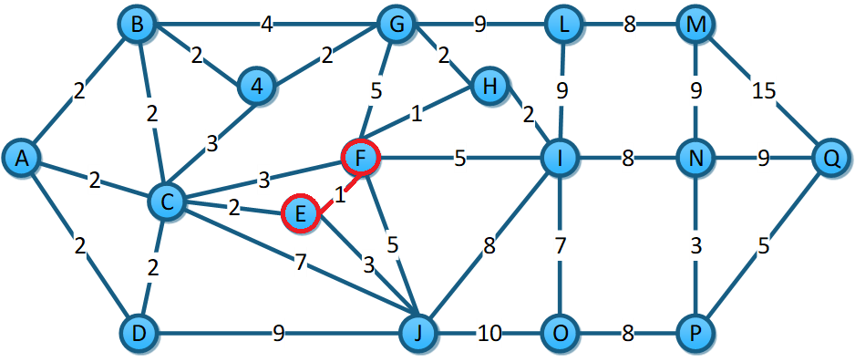

|  |  |
| --- | --- |
| E-F | 1 |
| F-H | 1 |
| A-B | 2 |
| A-C | 2 |
| A-D | 2 |
| B-C | 2 |
| C-D | 2 |
| B-4 | 2 |
| 4-G | 2 |
| C-E | 2 |
| G-H | 2 |
| H-I | 2 |
| C-4 | 3 |
| E-J | 3 |
| C-F | 3 |
| N-P | 3 |
| B-G | 4 |
| F-G | 5 |
| F-J | 5 |
| F-I | 5 |
| P-Q | 5 |
| C-J | 7 |
| I-O | 7 |
| J-I | 8 |
| L-M | 8 |
| I-N | 8 |
| O-P | 8 |
| D-J | 9 |
| G-L | 9 |
| L-I | 9 |
| N-M | 9 |
| N-Q | 9 |
| J-O | 10 |
| M-Q | 15 |

Tomamos H-F.

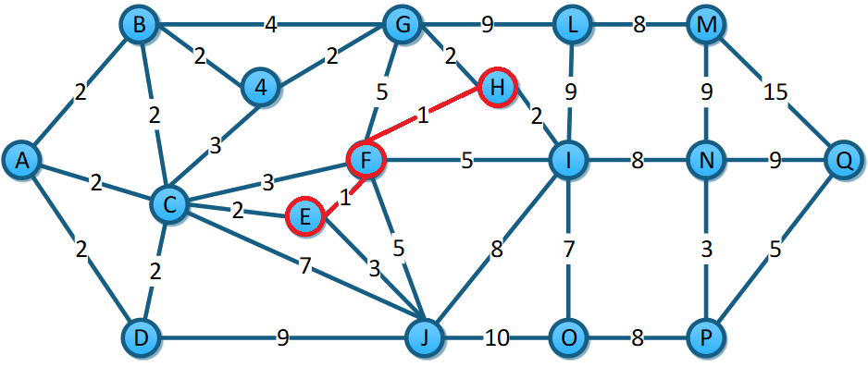

|  |  |
| --- | --- |
| E-F | 1 |
| F-H | 1 |
| A-B | 2 |
| A-C | 2 |
| A-D | 2 |
| B-C | 2 |
| C-D | 2 |
| B-4 | 2 |
| 4-G | 2 |
| C-E | 2 |
| G-H | 2 |
| H-I | 2 |
| C-4 | 3 |
| E-J | 3 |
| C-F | 3 |
| N-P | 3 |
| B-G | 4 |
| F-G | 5 |
| F-J | 5 |
| F-I | 5 |
| P-Q | 5 |
| C-J | 7 |
| I-O | 7 |
| J-I | 8 |
| L-M | 8 |
| I-N | 8 |
| O-P | 8 |
| D-J | 9 |
| G-L | 9 |
| L-I | 9 |
| N-M | 9 |
| N-Q | 9 |
| J-O | 10 |
| M-Q | 15 |

Tomamos A-B-

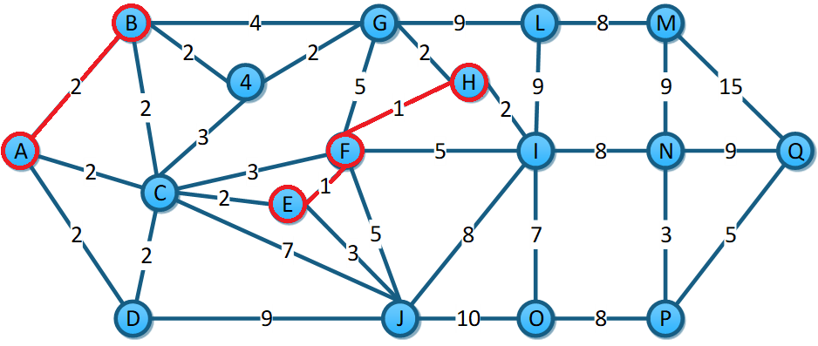

|  |  |
| --- | --- |
| E-F | 1 |
| F-H | 1 |
| A-B | 2 |
| A-C | 2 |
| A-D | 2 |
| B-C | 2 |
| C-D | 2 |
| B-4 | 2 |
| 4-G | 2 |
| C-E | 2 |
| G-H | 2 |
| H-I | 2 |
| C-4 | 3 |
| E-J | 3 |
| C-F | 3 |
| N-P | 3 |
| B-G | 4 |
| F-G | 5 |
| F-J | 5 |
| F-I | 5 |
| P-Q | 5 |
| C-J | 7 |
| I-O | 7 |
| J-I | 8 |
| L-M | 8 |
| I-N | 8 |
| O-P | 8 |
| D-J | 9 |
| G-L | 9 |
| L-I | 9 |
| N-M | 9 |
| N-Q | 9 |
| J-O | 10 |
| M-Q | 15 |

Tomamos A-C.

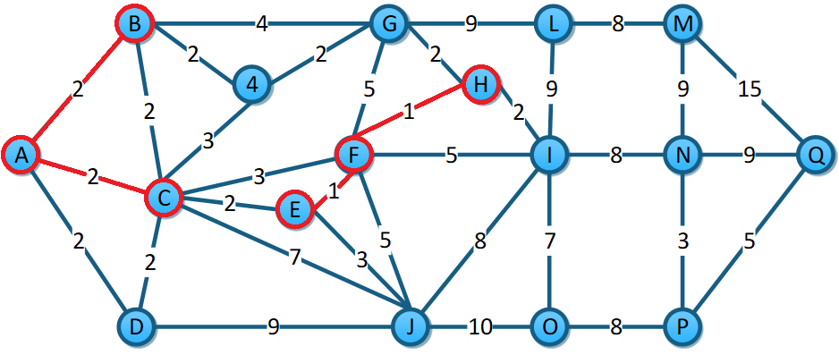

|  |  |
| --- | --- |
| E-F | 1 |
| F-H | 1 |
| A-B | 2 |
| A-C | 2 |
| A-D | 2 |
| B-C | 2 |
| C-D | 2 |
| B-4 | 2 |
| 4-G | 2 |
| C-E | 2 |
| G-H | 2 |
| H-I | 2 |
| C-4 | 3 |
| E-J | 3 |
| C-F | 3 |
| N-P | 3 |
| B-G | 4 |
| F-G | 5 |
| F-J | 5 |
| F-I | 5 |
| P-Q | 5 |
| C-J | 7 |
| I-O | 7 |
| J-I | 8 |
| L-M | 8 |
| I-N | 8 |
| O-P | 8 |
| D-J | 9 |
| G-L | 9 |
| L-I | 9 |
| N-M | 9 |
| N-Q | 9 |
| J-O | 10 |
| M-Q | 15 |

Tomamos A-D.

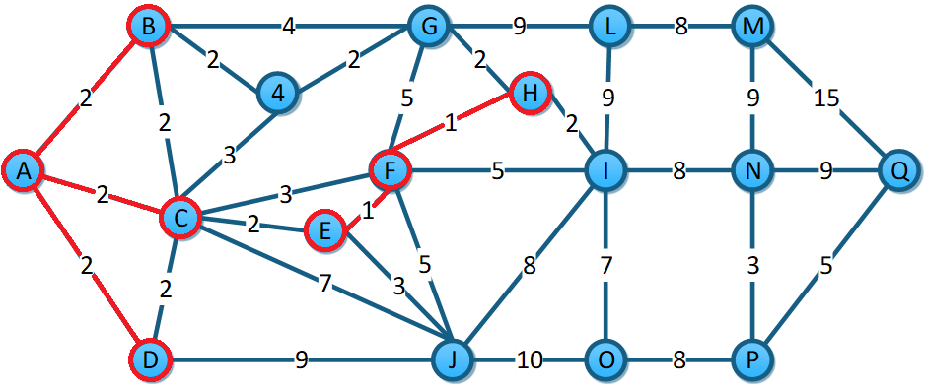

|  |  |
| --- | --- |
| E-F | 1 |
| F-H | 1 |
| A-B | 2 |
| A-C | 2 |
| A-D | 2 |
| B-C | 2 |
| C-D | 2 |
| B-4 | 2 |
| 4-G | 2 |
| C-E | 2 |
| G-H | 2 |
| H-I | 2 |
| C-4 | 3 |
| E-J | 3 |
| C-F | 3 |
| N-P | 3 |
| B-G | 4 |
| F-G | 5 |
| F-J | 5 |
| F-I | 5 |
| P-Q | 5 |
| C-J | 7 |
| I-O | 7 |
| J-I | 8 |
| L-M | 8 |
| I-N | 8 |
| O-P | 8 |
| D-J | 9 |
| G-L | 9 |
| L-I | 9 |
| N-M | 9 |
| N-Q | 9 |
| J-O | 10 |
| M-Q | 15 |

B-C y D-C hacen ciclo. Tomamos B-4.

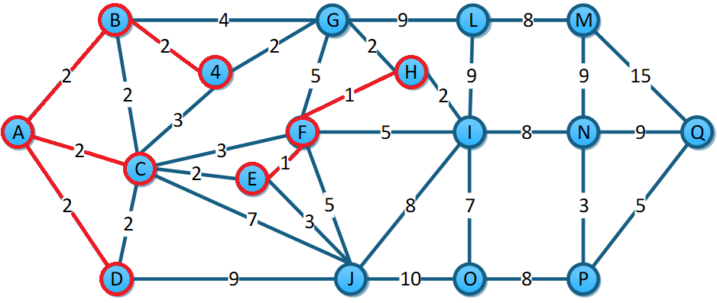

|  |  |
| --- | --- |
| E-F | 1 |
| F-H | 1 |
| A-B | 2 |
| A-C | 2 |
| A-D | 2 |
| ~~B-C~~ | ~~2~~ |
| ~~C-D~~ | ~~2~~ |
| B-4 | 2 |
| 4-G | 2 |
| C-E | 2 |
| G-H | 2 |
| H-I | 2 |
| C-4 | 3 |
| E-J | 3 |
| C-F | 3 |
| N-P | 3 |
| B-G | 4 |
| F-G | 5 |
| F-J | 5 |
| F-I | 5 |
| P-Q | 5 |
| C-J | 7 |
| I-O | 7 |
| J-I | 8 |
| L-M | 8 |
| I-N | 8 |
| O-P | 8 |
| D-J | 9 |
| G-L | 9 |
| L-I | 9 |
| N-M | 9 |
| N-Q | 9 |
| J-O | 10 |
| M-Q | 15 |

Tomamos 4-G.

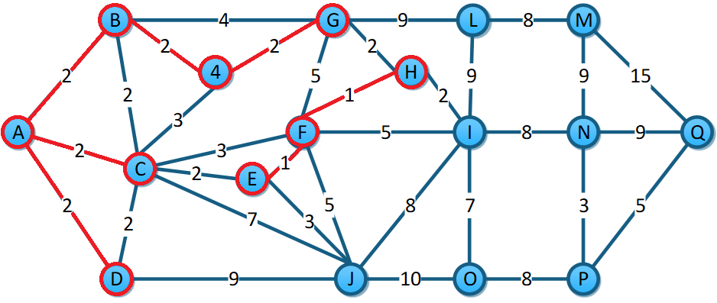

|  |  |
| --- | --- |
| E-F | 1 |
| F-H | 1 |
| A-B | 2 |
| A-C | 2 |
| A-D | 2 |
| ~~B-C~~ | ~~2~~ |
| ~~C-D~~ | ~~2~~ |
| B-4 | 2 |
| 4-G | 2 |
| C-E | 2 |
| G-H | 2 |
| H-I | 2 |
| C-4 | 3 |
| E-J | 3 |
| C-F | 3 |
| N-P | 3 |
| B-G | 4 |
| F-G | 5 |
| F-J | 5 |
| F-I | 5 |
| P-Q | 5 |
| C-J | 7 |
| I-O | 7 |
| J-I | 8 |
| L-M | 8 |
| I-N | 8 |
| O-P | 8 |
| D-J | 9 |
| G-L | 9 |
| L-I | 9 |
| N-M | 9 |
| N-Q | 9 |
| J-O | 10 |
| M-Q | 15 |

Tomamos C-E.

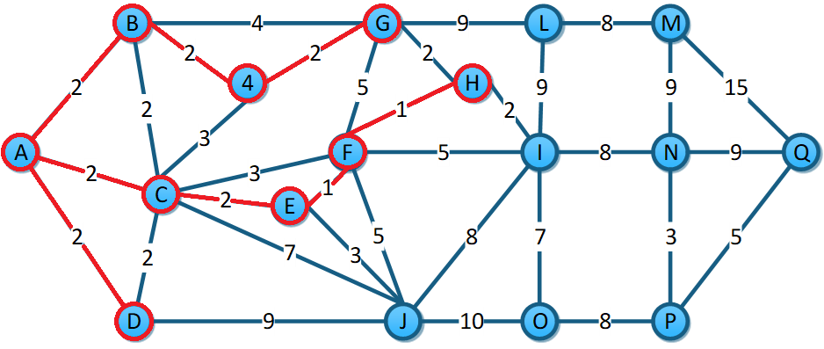

|  |  |
| --- | --- |
| E-F | 1 |
| F-H | 1 |
| A-B | 2 |
| A-C | 2 |
| A-D | 2 |
| ~~B-C~~ | ~~2~~ |
| ~~C-D~~ | ~~2~~ |
| B-4 | 2 |
| 4-G | 2 |
| C-E | 2 |
| G-H | 2 |
| H-I | 2 |
| C-4 | 3 |
| E-J | 3 |
| C-F | 3 |
| N-P | 3 |
| B-G | 4 |
| F-G | 5 |
| F-J | 5 |
| F-I | 5 |
| P-Q | 5 |
| C-J | 7 |
| I-O | 7 |
| J-I | 8 |
| L-M | 8 |
| I-N | 8 |
| O-P | 8 |
| D-J | 9 |
| G-L | 9 |
| L-I | 9 |
| N-M | 9 |
| N-Q | 9 |
| J-O | 10 |
| M-Q | 15 |

G-H hace silo por lo que lo descartamos. Tomamos H-I.

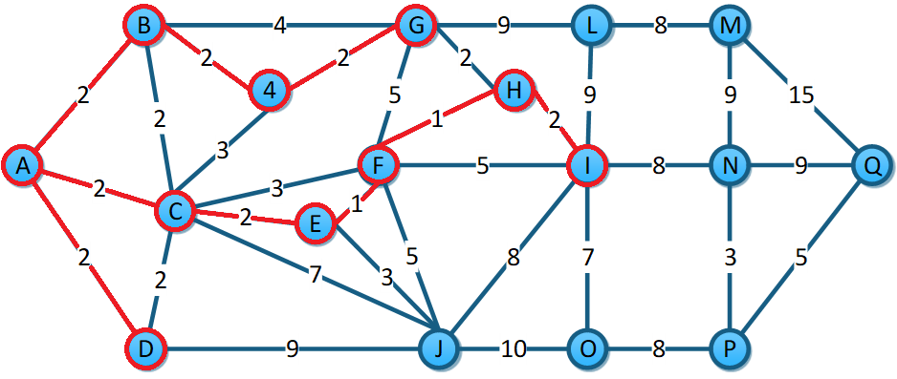

|  |  |
| --- | --- |
| E-F | 1 |
| F-H | 1 |
| A-B | 2 |
| A-C | 2 |
| A-D | 2 |
| ~~B-C~~ | ~~2~~ |
| ~~C-D~~ | ~~2~~ |
| B-4 | 2 |
| 4-G | 2 |
| C-E | 2 |
| ~~G-H~~ | ~~2~~ |
| H-I | 2 |
| C-4 | 3 |
| E-J | 3 |
| C-F | 3 |
| N-P | 3 |
| B-G | 4 |
| F-G | 5 |
| F-J | 5 |
| F-I | 5 |
| P-Q | 5 |
| C-J | 7 |
| I-O | 7 |
| J-I | 8 |
| L-M | 8 |
| I-N | 8 |
| O-P | 8 |
| D-J | 9 |
| G-L | 9 |
| L-I | 9 |
| N-M | 9 |
| N-Q | 9 |
| J-O | 10 |
| M-Q | 15 |

C-4 crea un ciclo. Tomamos E-J.

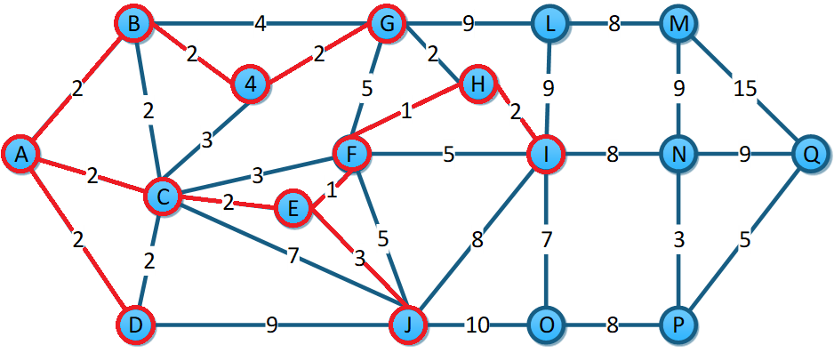

|  |  |
| --- | --- |
| E-F | 1 |
| F-H | 1 |
| A-B | 2 |
| A-C | 2 |
| A-D | 2 |
| ~~B-C~~ | ~~2~~ |
| ~~C-D~~ | ~~2~~ |
| B-4 | 2 |
| 4-G | 2 |
| C-E | 2 |
| ~~G-H~~ | ~~2~~ |
| H-I | 2 |
| ~~C-4~~ | ~~3~~ |
| E-J | 3 |
| C-F | 3 |
| N-P | 3 |
| B-G | 4 |
| F-G | 5 |
| F-J | 5 |
| F-I | 5 |
| P-Q | 5 |
| C-J | 7 |
| I-O | 7 |
| J-I | 8 |
| L-M | 8 |
| I-N | 8 |
| O-P | 8 |
| D-J | 9 |
| G-L | 9 |
| L-I | 9 |
| N-M | 9 |
| N-Q | 9 |
| J-O | 10 |
| M-Q | 15 |

Descartamos C-F. Vamos a usar N-P.

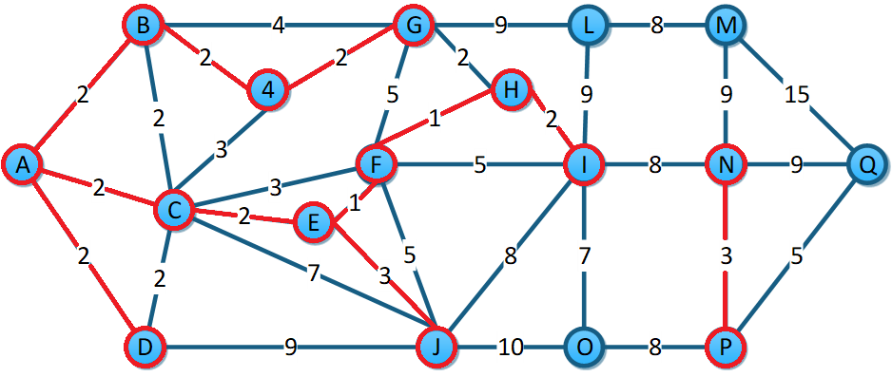

|  |  |
| --- | --- |
| E-F | 1 |
| F-H | 1 |
| A-B | 2 |
| A-C | 2 |
| A-D | 2 |
| ~~B-C~~ | ~~2~~ |
| ~~C-D~~ | ~~2~~ |
| B-4 | 2 |
| 4-G | 2 |
| C-E | 2 |
| ~~G-H~~ | ~~2~~ |
| H-I | 2 |
| ~~C-4~~ | ~~3~~ |
| E-J | 3 |
| ~~C-F~~ | ~~3~~ |
| N-P | 3 |
| B-G | 4 |
| F-G | 5 |
| F-J | 5 |
| F-I | 5 |
| P-Q | 5 |
| C-J | 7 |
| I-O | 7 |
| J-I | 8 |
| L-M | 8 |
| I-N | 8 |
| O-P | 8 |
| D-J | 9 |
| G-L | 9 |
| L-I | 9 |
| N-M | 9 |
| N-Q | 9 |
| J-O | 10 |
| M-Q | 15 |

De B-G a F-I se forman ciclos por lo que se desechan. Se usa P-Q.

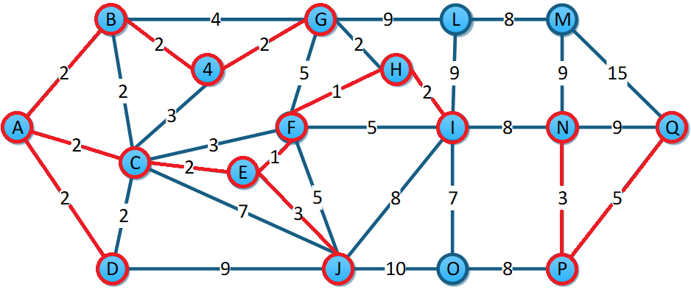

|  |  |
| --- | --- |
| E-F | 1 |
| F-H | 1 |
| A-B | 2 |
| A-C | 2 |
| A-D | 2 |
| ~~B-C~~ | ~~2~~ |
| ~~C-D~~ | ~~2~~ |
| B-4 | 2 |
| 4-G | 2 |
| C-E | 2 |
| ~~G-H~~ | ~~2~~ |
| H-I | 2 |
| ~~C-4~~ | ~~3~~ |
| E-J | 3 |
| ~~C-F~~ | ~~3~~ |
| N-P | 3 |
| ~~B-G~~ | ~~4~~ |
| ~~F-G~~ | ~~5~~ |
| ~~F-J~~ | ~~5~~ |
| ~~F-I~~ | ~~5~~ |
| P-Q | 5 |
| C-J | 7 |
| I-O | 7 |
| J-I | 8 |
| L-M | 8 |
| I-N | 8 |
| O-P | 8 |
| D-J | 9 |
| G-L | 9 |
| L-I | 9 |
| N-M | 9 |
| N-Q | 9 |
| J-O | 10 |
| M-Q | 15 |

C-J hace ciclo, usamos I-O.

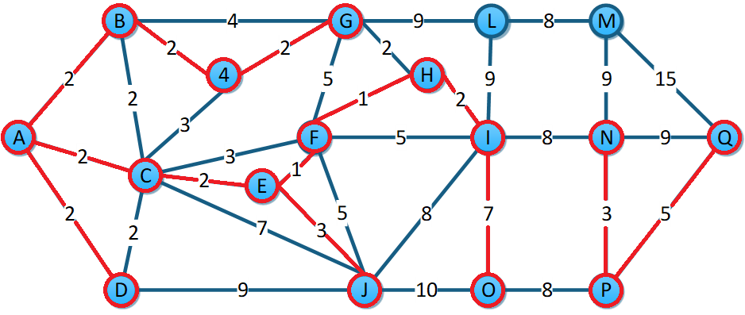

|  |  |
| --- | --- |
| E-F | 1 |
| F-H | 1 |
| A-B | 2 |
| A-C | 2 |
| A-D | 2 |
| ~~B-C~~ | ~~2~~ |
| ~~C-D~~ | ~~2~~ |
| B-4 | 2 |
| 4-G | 2 |
| C-E | 2 |
| ~~G-H~~ | ~~2~~ |
| H-I | 2 |
| ~~C-4~~ | ~~3~~ |
| E-J | 3 |
| ~~C-F~~ | ~~3~~ |
| N-P | 3 |
| ~~B-G~~ | ~~4~~ |
| ~~F-G~~ | ~~5~~ |
| ~~F-J~~ | ~~5~~ |
| ~~F-I~~ | ~~5~~ |
| P-Q | 5 |
| ~~C-J~~ | ~~7~~ |
| I-O | 7 |
| J-I | 8 |
| L-M | 8 |
| I-N | 8 |
| O-P | 8 |
| D-J | 9 |
| G-L | 9 |
| L-I | 9 |
| N-M | 9 |
| N-Q | 9 |
| J-O | 10 |
| M-Q | 15 |

J-I crea un ciclo. Usamos L-M.

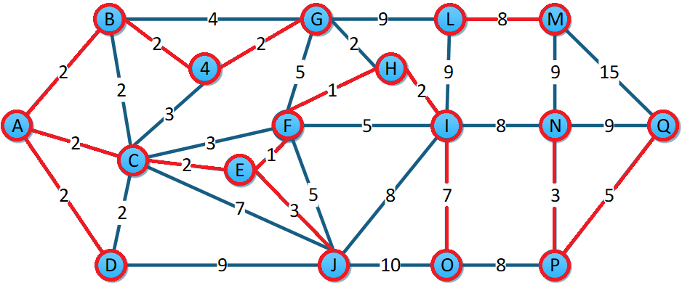

|  |  |
| --- | --- |
| E-F | 1 |
| F-H | 1 |
| A-B | 2 |
| A-C | 2 |
| A-D | 2 |
| ~~B-C~~ | ~~2~~ |
| ~~C-D~~ | ~~2~~ |
| B-4 | 2 |
| 4-G | 2 |
| C-E | 2 |
| ~~G-H~~ | ~~2~~ |
| H-I | 2 |
| ~~C-4~~ | ~~3~~ |
| E-J | 3 |
| ~~C-F~~ | ~~3~~ |
| N-P | 3 |
| ~~B-G~~ | ~~4~~ |
| ~~F-G~~ | ~~5~~ |
| ~~F-J~~ | ~~5~~ |
| ~~F-I~~ | ~~5~~ |
| P-Q | 5 |
| ~~C-J~~ | ~~7~~ |
| I-O | 7 |
| ~~J-I~~ | ~~8~~ |
| L-M | 8 |
| I-N | 8 |
| O-P | 8 |
| D-J | 9 |
| G-L | 9 |
| L-I | 9 |
| N-M | 9 |
| N-Q | 9 |
| J-O | 10 |
| M-Q | 15 |

Usamos I-N.

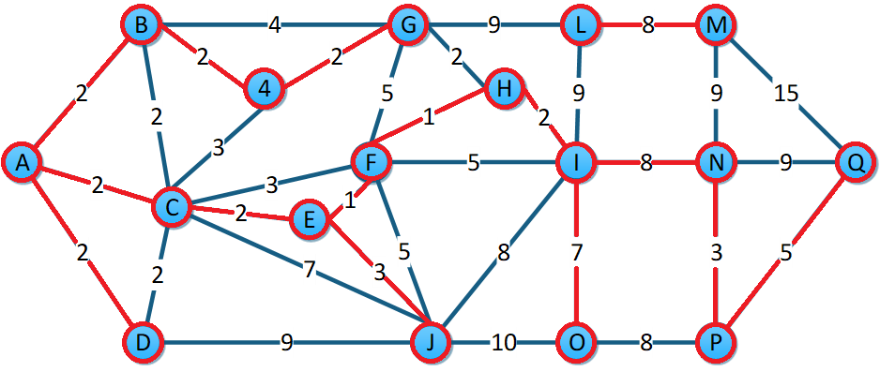

|  |  |
| --- | --- |
| E-F | 1 |
| F-H | 1 |
| A-B | 2 |
| A-C | 2 |
| A-D | 2 |
| ~~B-C~~ | ~~2~~ |
| ~~C-D~~ | ~~2~~ |
| B-4 | 2 |
| 4-G | 2 |
| C-E | 2 |
| ~~G-H~~ | ~~2~~ |
| H-I | 2 |
| ~~C-4~~ | ~~3~~ |
| E-J | 3 |
| ~~C-F~~ | ~~3~~ |
| N-P | 3 |
| ~~B-G~~ | ~~4~~ |
| ~~F-G~~ | ~~5~~ |
| ~~F-J~~ | ~~5~~ |
| ~~F-I~~ | ~~5~~ |
| P-Q | 5 |
| ~~C-J~~ | ~~7~~ |
| I-O | 7 |
| ~~J-I~~ | ~~8~~ |
| L-M | 8 |
| I-N | 8 |
| O-P | 8 |
| D-J | 9 |
| G-L | 9 |
| L-I | 9 |
| N-M | 9 |
| N-Q | 9 |
| J-O | 10 |
| M-Q | 15 |

O-P y D-J forman ciclos. Conectamos G con L.

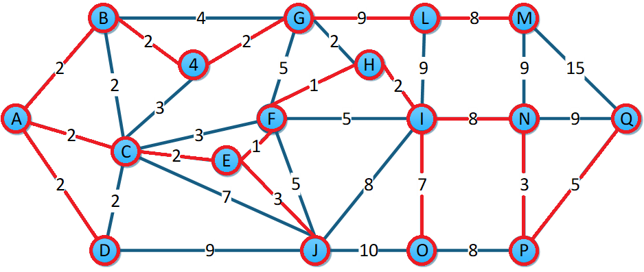

|  |  |
| --- | --- |
| E-F | 1 |
| F-H | 1 |
| A-B | 2 |
| A-C | 2 |
| A-D | 2 |
| ~~B-C~~ | ~~2~~ |
| ~~C-D~~ | ~~2~~ |
| B-4 | 2 |
| 4-G | 2 |
| C-E | 2 |
| ~~G-H~~ | ~~2~~ |
| H-I | 2 |
| ~~C-4~~ | ~~3~~ |
| E-J | 3 |
| ~~C-F~~ | ~~3~~ |
| N-P | 3 |
| ~~B-G~~ | ~~4~~ |
| ~~F-G~~ | ~~5~~ |
| ~~F-J~~ | ~~5~~ |
| ~~F-I~~ | ~~5~~ |
| P-Q | 5 |
| ~~C-J~~ | ~~7~~ |
| I-O | 7 |
| ~~J-I~~ | ~~8~~ |
| L-M | 8 |
| I-N | 8 |
| ~~O-P~~ | ~~8~~ |
| ~~D-J~~ | ~~9~~ |
| G-L | 9 |
| L-I | 9 |
| N-M | 9 |
| N-Q | 9 |
| J-O | 10 |
| M-Q | 15 |

Terminamos el árbol de expansión mínima.

## Dijkstra:

Camino más corto de A-Q.

|  |  |  |  |  |  |  |  |  |  |
| --- | --- | --- | --- | --- | --- | --- | --- | --- | --- |
| Vértices |  |  |  |  |  |  |  |  |  |
| A | (0,A) | * | * | * | * | * | * | * | * |
| B | (2,A) | (4,C) | ∞ | ∞ |  |  |  |  |  |
| C | (2,A)-> | (2,A) | * | * | * | * | * | * | * |
| D | (2,A) | (4,C) | ∞ | ∞ | ∞ | ∞ | ∞ | ∞ | ∞ |
| E | ∞ | (4,C)-> | (4,C) | * | * | * | * | * | * |
| F | ∞ | (5,C) | (5,E)-> | (5,E) | * | * | * | * | * |
| G | ∞ | ∞ | ∞ | (10,F) | (8,H) | ∞ | ∞ | ∞ | ∞ |
| H | ∞ | ∞ | ∞ | (6,F)-> | (6,F) | * | * | * | * |
| I | ∞ | ∞ | ∞ | (10,F) | (8,H)-> | (8,H) | * | * | * |
| J | ∞ | (9,C) | (7,E) | (10,F) | ∞ | (16,I) | ∞ | ∞ | ∞ |
| 4 | ∞ | (5,C) | ∞ | ∞ | ∞ | ∞ | ∞ | ∞ | ∞ |
| L | ∞ | ∞ | ∞ | ∞ | ∞ | (17,I) | ∞ | ∞ | ∞ |
| M | ∞ | ∞ | ∞ | ∞ | ∞ | ∞ | (25,N) | ∞ | ∞ |
| N | ∞ | ∞ | ∞ | ∞ | ∞ | (16,I)-> | (16,I) | * | * |
| O | ∞ | ∞ | ∞ | ∞ | ∞ | (15,I) | ∞ | (27,P) | ∞ |
| P | ∞ | ∞ | ∞ | ∞ | ∞ | ∞ | (19,N)-> | (19,N) | * |
| Q | ∞ | ∞ | ∞ | ∞ | ∞ | ∞ | (25,N) | (24,P)-> | (24,P) |